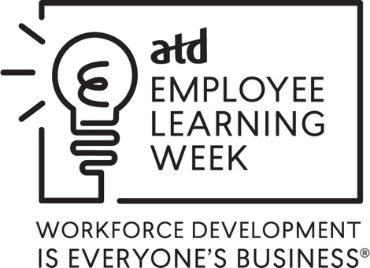

Media Tips and Talking Points

While your organization or chapter is making plans to promote Employee Learning Week locally, you may want to contact business or workplace reporters at your local paper to discuss your planned activities and events. As you prepare for this outreach, here are some tips from the ATD Communications department.

Know your media. Research the reporter, media type, and intended audience to learn more about the topics that the paper and reporter usually cover. This will give you an idea of the angle you want to take when pitching the reporter.

Provide facts and resources. Develop a fact sheet or press release template and include all relevant information about your ELW plans. Be sure to designate someone as the point of contact so that the reporter knows whom to call in the future.

Connect to ATD information and resources. Many of the ATD Employee Learning Week materials are available online so that you can download or print copies of the brochures and postcards and adapt the ideas on the local level.

Included below is a sample language that you may want to use when working with the media.

(Your chapter/organization name) is planning activities (or an event) during ATD Employee Learning Week, December 2-6, 2024. This is an opportunity for organizations to highlight the important connection between learning and achieving organizational results. We encourage our local media to cover the activities and events or write a story about the importance of employee learning and development.

The sponsoring organization of Employee Learning Week is ATD, the Association for Talent Development, the world’s largest association dedicated to those who develop talent in organizations. The (chapter name) represents learning and performance professionals in the (city/town information here). (Add more about your local chapter here.)

(Your organization name) is holding (event/activities) on (date/time) at (location). Last year, over 100 organizations and ATD chapters recognized Employee Learning Week through events, meetings, and communication with members. Several ATD chapters recognized the week through Employee Learning Week proclamations in their city, county, or state.

