Volunteer Activity Description
Virtual Flagship Events Producer
Learning Programs

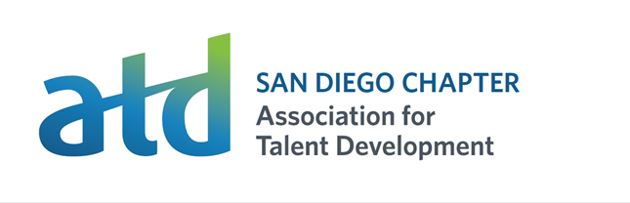

Overview and Importance to ATD San Diego Chapter’s Mission: Our mission is to inspire, grow, and connect talent and organizational development professionals in San Diego. The Virtual Flagship Events Producer plays a vital role in ensuring ATD San Diego’s main speaker events run smoothly and successfully when they are held online. This volunteer acts as a producer, promoter, and task manager, supporting the event speaker while fostering an engaging and interactive experience for attendees.

As a Virtual Flagship Event Producer, you will be the crucial behind-the-scenes force ensuring a seamless and engaging experience for our virtual flagship events. Your focus will be on enhancing audience engagement, providing technical assistance, and actively promoting the chapter's offerings.

Point of Contact: Director of Programs, Events@tdsandiego.org

Time Commitment: Several Virtual Flagship Events per year. Dates and times vary.

Location: Virtual over Zoom

Training
  - Volunteer Interview
  - Shadow shift
  - Other trainings may be assigned

Volunteer Duties may include:
- Register for the event you will be leading or co-hosting by selecting it from the ATD events calendar.
  - Select “Add to My Calendar” on the event registration page.
  - You will receive a confirmation email with the Zoom link.
- Arrive in the virtual room 15 minutes before the session starts.
- At the event start time (not early) admit attendees from the waiting room.
- Greet people and make conversation.
- Provide technology support, if needed (for people unfamiliar with the platform or virtual meetings in general).
- ~10 minutes after session start, take attendance by typing names in a Google Doc or taking a screenshot of the gallery with all participants showing.
  - Send the attendance to the Director of Learning Programs, Kim Denton.

- Monitor the chat for audience needs/questions.
- Actively participate in the chat, engaging with audience members who like to connect there.
- Contribute to the discussion and help create a positive experience for everyone.
- Promote the event by sharing it on social media channels and talking to members and non-members about the upcoming event (encouraging people to attend).
- Promote upcoming chapter events by mentioning them during conversation and placing links in the chat.
  - Place link to the member calendar: https://www.tdsandiego.org/events?EventViewMode=1&EventListViewMode=2&SelectedDate=3/12/2025&CalendarViewType=0
  - Place link to join our chapter in the chat: https://tdsandiego.org/join
- One week prior to the event, virtually meet for 15 minutes with the event speaker and ATD Director of Learning Programs to confirm the working room link and go over logistics.
- During the event, write down action items that need follow-up after the event. Share those with Director of Learning Programs.
- Post positive post-event comments in social media, use the chapter hashtag, and include a link to the chapter calendar of events: https://www.tdsandiego.org/events?EventViewMode=1&EventListViewMode=2&SelectedDate=3/12/2025&CalendarViewType=0

Requirements:
- Comfortable speaking to large groups of people with the ability to explain ATD San Diego Chapter’s mission.
- Comfortable facilitating basic features of Zoom.
- Access to a computer with a camera and microphone.
- Ability to read, write and speak English.
- Possess good guest relations skills.
- Have an email account and access to the internet. Utilize both to schedule your shifts and stay up to date on changes in your program.
- Willingness to act professionally and treat each program guest with respect.
- Be a positive, self-motivated, mature, responsible, and sensitive team player.
- Ability and willingness to follow directions and constructive feedback. Your ATD contact will coach, counsel, and terminate as necessary.
- Have fun creating an enjoyable and valuable experience for members and yourself!

Professional Skills you can learn and practice:
- Communication and guest relations skills
- Facilitation skills
- Technology skills

Work Environment: Work environment takes place virtually over Zoom and requires use of a camera and microphone.

Dress Code: Business casual

