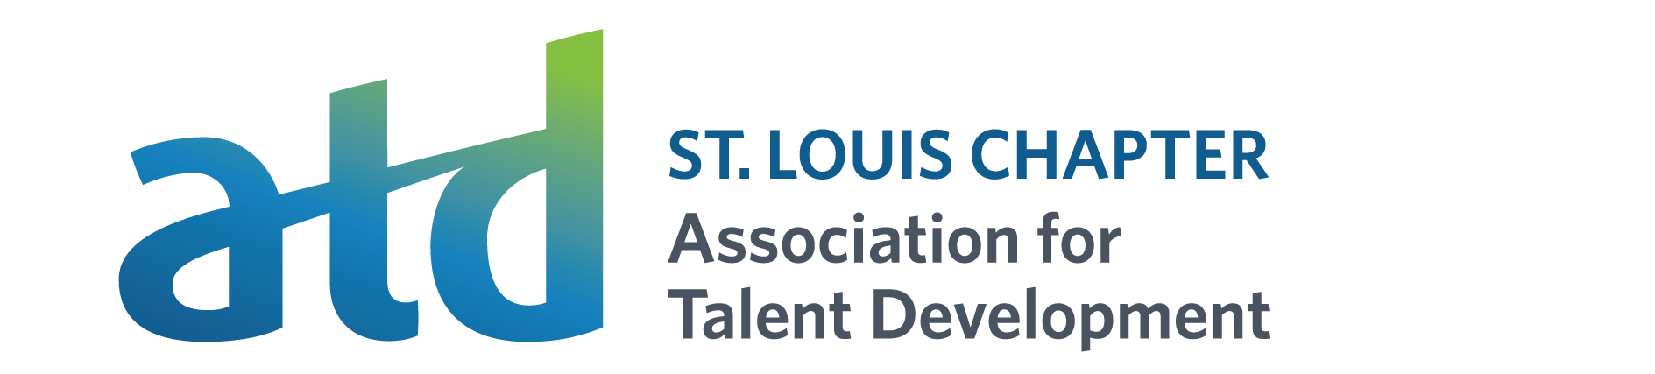
CHAPTER SPONSORSHIP PROGRAM 2025
The Association for Talent Development (ATD) Chapter can help you promote your organization! By sponsoring our chapter, you can market your business to the learning and development community.
Your organization will benefit from ongoing exposure to current and potential clients through our website, announcements at chapter events, and presentations throughout the year.
Sponsorship Benefits  (One year term) | Bronze Level  $$$ | Silver Level  $$$ | Gold Level  $$$ | Platinum Level  $$$

