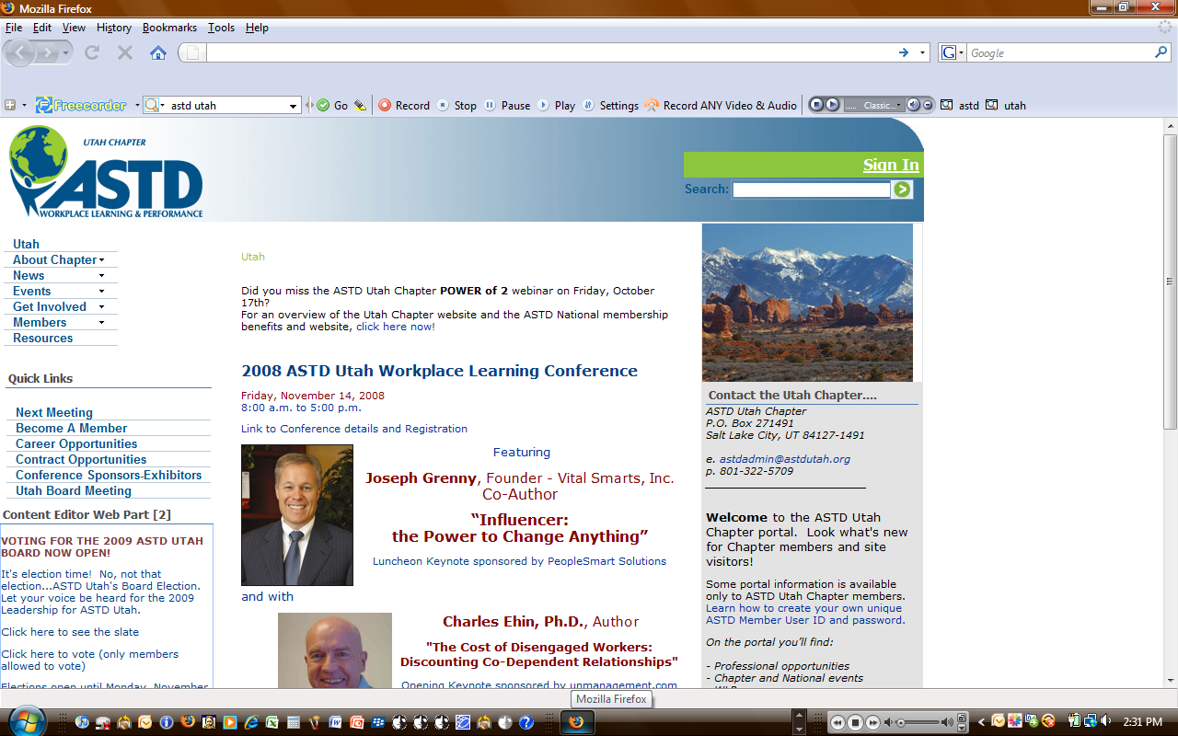**2009 Workplace Learning Conference  
University Park Marriott Hotel • 480 Wakara Way • Salt Lake City, UT**

**Opening Keynote** 🙢 **Bonneville Ballroom**

**A Culture of Learning: The Importance of Social Learning in Today's Workplace •** David Mallon, Senior Associate *Bersin & Associates*

**Luncheon Keynote** 🙢 **Bonneville Ballroom**

|  |  |  |  |
| --- | --- | --- | --- |
| **Morning Workshops**  **(9:30 – 11:40 - 2 Hours Each)** | **Breakout Sessions I**  **(1:15 – 2:15)** | **Breakout Sessions II**  **(2:30 – 3:30)** | **Other Highlights:** |
| **10 Online Training Do’s and Don’ts**  *Andrew Scivally • Zions Bank*  **Experiential Learning: More Than Just Games**  *Brandon Harrison • TeamSmart Teambuilding*  **Concepts to Credits: How to Make In-House Training Videos**  *Jay Naumann, RC Willey & Wes Stockmann, Nicholas & Co.*  **Trainer – Know Thyself!**  *Terri Lorz • University of Utah* | **The Carrot Principle**  *Pat Poyfair • OC Tanner/The Carrot Culture Group*  **Immediate Impact: Training Rollouts That Pay Off Quickly**  *Darrell Harmon • PeopleSmart*  **A Recipe for Training Success**  *Margo Beecher • University of Utah Health Sciences Center*  **Blended Learning**  *Mike Hassett • Allen Communications* | **Metaphor Magic: Using Symbolism in Learning**  *Laura Arellano • Meta Logia*  **Helping People With Change**  *Ron Cohn • Ralston Consulting Group*  **RISC: A New Model for Measuring Learning Success**  *Jacob Bunker • FamilySearch (LDS Church)*  **Four Generations in the Workplace: Is it a Big Deal?**  *Pat Wittmann • Questar Corporation* | **Networking Opportunities with Workplace Learning Professionals**  **CPLP Information Table**  **Vendor and Sponsor Giveaways**  **Closing Remarks with Fred Ball, Senior Vice President of Zions Bank and the Voice of *Speaking on Business*** |
|  | | | |

**Building Business Acumen - Gaining Personal Credibility! •** Ben Cook, VP of Strategy, *Acumen Learning*

**Workshops**

**Morning Workshops (9:30 – 11:40 - 2 Hours Each)**

|  |  |  |
| --- | --- | --- |
| **Presenter** | **Location** | **Topic** |
| **10 Online Training Do’s and Don’ts**  *Andrew Scivally • Zions Bank* | Bonneville Ballroom | Explore the Top 10 Do's and Don'ts for building effective eLearning. Topics include: who to hire, how to brand, graphic creation, interactivity, standards, and more. If your team is new to eLearning or has been doing it for years, come join the discussion. |
| **Experiential Learning: More Than Just Games**  *Brandon Harrison • TeamSmart Teambuilding* | Connor Room | Fun, unusual, active, and entertaining! This presentation is for those who want to experience a different twist to training and development, as well as those who want to laugh and have fun. Participants will be learning by doing. All will enjoy, including those people who already incorporate experiential activities in their work, or those who want to be introduced to it. Games, laughter, and play are very valuable, and do have their place. |
| **Concepts to Credits: How to Make In-House Training Videos**  *Jay Naumann, RC Willey &  Wes Stockmann, Nicholas & Co.* | Amphitheater | Concept to Credits will show you how to make in-house training videos from beginning to end. You constantly hear that you should include video in your eLearning and live presentations – but how? We’ll show you how easy and inexpensive it can be. Learners will take an active role in filming, editing, and producing a training video. Key concepts of lighting, sound, shot framing, editing software, and final production will be covered. |
| **Trainer – Know Thyself!**  *Terri Lorz • University of Utah* | Ft. Douglas*  Change in venue | Resonating with your participants resides in your ability to know yourself. But self knowledge can be elusive. It is often contained in a puzzle of feedback, so-called criticisms and failures and fears. This training is designed to lead trainers through exercises that reveal the hidden nuggets of truth and insight hidden in these experience and support trainers in being authentic, confident and comfortable. |

**Afternoon Breakout Session I (1:15 – 2:15)**

|  |  |  |
| --- | --- | --- |
| **Presenter** | **Location** | **Topic** |
| **The Carrot Principle**  *Pat Poyfair • OC Tanner/The Carrot Culture Group* | Bonneville Ballroom | The Carrot Principle Keynote Speech highlights proven ideas, powerful case studies and examples to show how recognition engages people and improves your bottom line. This lively, humorous session teaches principles that will help managers build more effective relationships with each of their employees. Featuring leadership concepts from The New York Times bestselling book The Carrot Principle, it’s a no-holds-barred, high-energy, high-level event that entertains and inspires. Recognition changes everything – come find out how! |
| **Immediate Impact: Training Rollouts That Pay Off Quickly**  *Darrell Harmon • PeopleSmart* | Connor Room | Training’s goal has always been to produce permanent, measurable improvements in job performance that positively impact business results. Yet most of us struggle to ensure that participants return from training capable of using new skills back on the job. Based on our recent publication, voted MIT’s Sloan Management Review Change Article of the Year, we’ll explore six sources of training transfer, backed by research into their effectiveness. |
| **A Recipe for Training Success**  *Margo Beecher • University of Utah Health Sciences Center* | Ft. Douglas* Change in venue | More than a century ago in the introduction to one of their cookbooks, the Pillsbury Company wrote, *"The failure or incomplete success of a recipe oftentimes depends upon some little detail that has been misunderstood or overlooked ..."* That statement could apply as much to training as to cooking since leaving out an important detail in the development or delivery of training can spoil the intended outcomes. Including a careful measure of nine essential ingredients in your training, though, can help ensure successful results time after time. Attend this session and sample a blend of nine ingredients that are a must in any recipe for training success. |
| **Blended Learning**  *Mike Hassett • Allen Communications* | Amphitheater | Is blended learning really 2400 years old? We’ll look at a Platonic dialogue to answer that question, then we’ll use that historical springboard to dive into the why, when, what and how of contemporary blended learning. We’ll look at examples of real companies that are currently blending their learning in effective and interesting ways, and we’ll end by inviting participants to pose their own needs for blended learning for group discussion. |

**Afternoon Breakout Session II (2:30 – 3:30)**

|  |  |  |
| --- | --- | --- |
| **Presenter** | **Location** | **Topic** |
| **Metaphor Magic: Using Symbolism in Learning**  *Laura Arellano • Meta Logia* | Bonneville Ballroom | Would you say that learning is like the Ocean? Or a Sponge? Or a Cookie? As seasoned trainers, we know that attention and retention are dramatically increased when we integrate various sensory dimensions into our training programs - dimensions such as hearing the information, seeing, reading and experiencing it. We’ve even enhanced the learning environment with music and stimulating scents. The next step in increasing retention is to activate the subconscious, engage the whole-brain and stimulate the imagination. |
| **Helping People With Change**  *Ron Cohn • Ralston Consulting Group* | Connor Room | Today's workplace is riddled with change. Changes in company structure, employee benefits, worker demographics, and technology coupled with the ever present concern of downsizing makes for an unsettling environment. This interactive presentation will focus on the personal transitions people experience while attempting to cope with these changes. This session will be for those personally dealing with these moments as well as professionals charged with assisting them. |
| **RISC: A New Model for Measuring Learning Success**  *Jacob Bunker • FamilySearch (LDS Church)* | Amphitheater | Did you know there is a 58% increase in the need to measure and report the value of eLearning programs? Would it surprise you to know that in that same study 51% of learning professionals self-reported that they do not currently have systems for measuring value, and that they don’t plan too! How can we meet the rising expectation to accurately report our comprehensive worth to top executives while not draining our teams of crucial resources to do complex ROI calculations? In this interactive session Jacob will describe the RISC model for convincingly defending the presenting the value of eLearning programs to your top executives quickly and defensibly. Reap the benefits of being a proven trusted business contributor while maintaining your ability to focus on solving business problems. |
| **Four Generations in the Workplace: Is it a Big Deal?**  *Pat Wittmann • Questar Corporation* | Ft. Douglas* Change in venue | What’s the Big Deal? Understanding four generations of workers is important to your success. Each generation feels, behaves and responds differently – whether they recognize it or not. The key is to know how to work with each generation and all of the generations at the same time. Understanding what makes each generation tick is the basis for generational accord in today’s workplace. In this presentation, you will learn:   * The history behind each generation; what makes them who they are today * What are their expectations in the workplace? * How do they define success? * How can we bring them together in peace and harmony? * Tips for trainers to engage all generations in your programs |