ATD26 Proposal Worksheet
This worksheet is designed to allow you to create your proposal prior to submitting it to our CFP portal. This worksheet will allow you to:
- Review and develop proposal requirements prior to entering the system.
- Easily share your proposal with others to gather feedback.
Please download a copy of the worksheet and save it for your use.
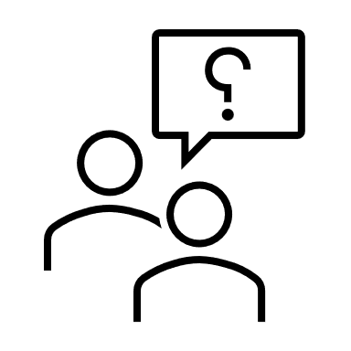 Proposal Overview and Background
Title (Limited to 10 Words). Tips for Developing a Great Title.
Proposal Type (See list here).
Speaker Types (Please note the descriptions for the two speaker types).
New ATD Speaker
At least one speaker included in this proposal (including yourself) has not presented at an ATD event within the past five years, specifically the ATD International Conference & EXPO, ATD TechKnowledge, ATD Core4, ATD OrgDev, ATD SELL, or ATD Government Workforce.
Note: All new ATD speakers are required to submit a video demonstrating previous speaking experience.
Returning ATD Speaker
All speakers included in this proposal (including yourself) have presented at one or more ATD events. Specifically, the ATD International Conference & EXPO, ATD TechKnowledge, ATD Core4, ATD OrgDev, ATD SELL, or ATD Government Workforce.
____________________________________________________________________________________
TASK 1- SESSION PROPOSAL
Track and Area of Focus (See list here):
Knowledge Level (Beginner, Intermediate, Advanced) (See list here):
Optional: Select an ATD Talent Development Capability Model (See list here)
Target Audience (See list here)
Proposal Overview:
This section is for INTERNAL REVIEW USE ONLY. Our submission process is highly competitive. This section helps reviewers gain a clear and thorough understanding of your session and its value to our program. Use this space to provide a deeper dive into your session's content. Explain why your proposal is a strong fit for the selected track and give a comprehensive overview of what you plan to present. This overview should go beyond the short version intended for attendees. Be sure to include:
- What key themes, topics, tools, or approaches will your session cover?
- Use this area to clearly explain why you selected the target audience and knowledge level, and how each one supports and aligns with your session content.

Subject Matter Background:
Please provide essential background on your subject matter/topic. Include your, and any additional presenters’, years of experience in this area and what made you propose a session on this subject/topic.
Topic Importance:
Please explain why this topic is important to this industry.
____________________________________________________________________________________________
TASK 2- SUBMISSION DETAILS
Has this session been presented at any other events (including ATD events?
Yes/No
If yes, please list the name of the conference at which it was presented and the dates.

If this has been presented before, is your plan to present the same version shared at past events, or do you plan to change it for ATD26?
Note: If you plan to make substantial updates for the ATD 2026 International Conference & EXPO, we recommend revising the session title and description, so it is clear to attendees that this presentation has content they haven't seen at any event before. If you selected "No" for Question 1, please enter "N/A" in the field below,
Could this session be delivered in a hybrid format?
A small number of sessions will be live streamed to virtual attendees. The live stream will include video of the room and stage, audio, and slides projected to the virtual audience. We expect live stream speakers to engage with both in-person and virtual attendees. Your answer will not hinder your proposal from being selected.
Yes/No
Does this session offer a global perspective on the topic?
If yes, please explain below. If not, enter N/A.
____________________________________________________________________________________
TASK 3- SPEAKER INFORMATION
If you have a second speaker, please enter their information. If you are proposing a panel discussion, you may enter up to 5 speakers including yourself.
____________________________________________________________________________________
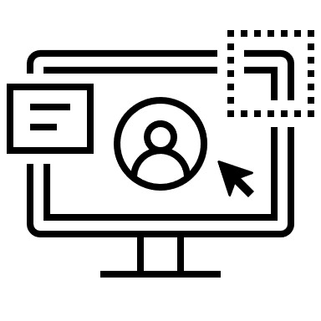 Proposed Session Design
TASK 4- SESSION DESCRIPTION AND AGENDA
Session Description
This is designed to be a short, succinct description of your session that, IF SELECTED, would be used for the public-facing program guide, app, website, and any potential marketing pieces. Write this directly to attendees as a quick pitch about why they should attend your session. Please don’t simply repeat what you entered in the session proposal. Be sure to include any challenges you will address, describe potential solutions, or what attendees will gain by attending. Attendees expect that the session description is an accurate representation of what will be presented and what they will achieve by attending. (character limit is 750)

Session Agenda
We’re looking for an outline that demonstrates how your session will deliver stated outcomes; how it aligns with the session type you selected; and the specific area of focus you plan to cover. Please include how the session will be structured and flow from start to finish.
What challenges or questions will this session help attendees solve?
In one sentence, summarize the key perspective the audience will leave with.
____________________________________________________________________________________
TASK 5 – SESSION LEARNING OUTCOMES
Please provide 1-3 learning outcomes. (Writing Effective Learning Outcomes)
Outcomes should complete the sentence, “After attending this session, participants will be able to.”
These outcomes should demonstrate how attendees can apply what they’ve learned from your session to their work. Please use action verbs and action-oriented statements, such as explore, discover, utilize, apply, etc. Please provide clear, measurable, and achievable learning outcomes that attendees can expect to gain from your session.
____________________________________________________________________________________________
 Supporting Proposal Materials
In this section, you will include additional materials that will support your submission.
- Presentation example - (PowerPoint, PDF, Keynote) Include 4-6 slides max. These slides should demonstrate and reflect the topic you are proposing and your approach to presentation visual design.
- Video example- (Video file upload or URL) All new ATD speakers are required to submit a sample video presentation.
____________________________________________________________________________________
 Policies and Finalize Submission
In this section, you will review speaker and conference policies and finalize and submit your proposal.
Pro-Tip: When you are completing your proposal in the system, please make sure to save each task so that you can come back to the proposal and edit it prior to the submission deadline. Unsaved information will be lost. Use the save button at the bottom of the page after each task to make sure your information is not lost.

