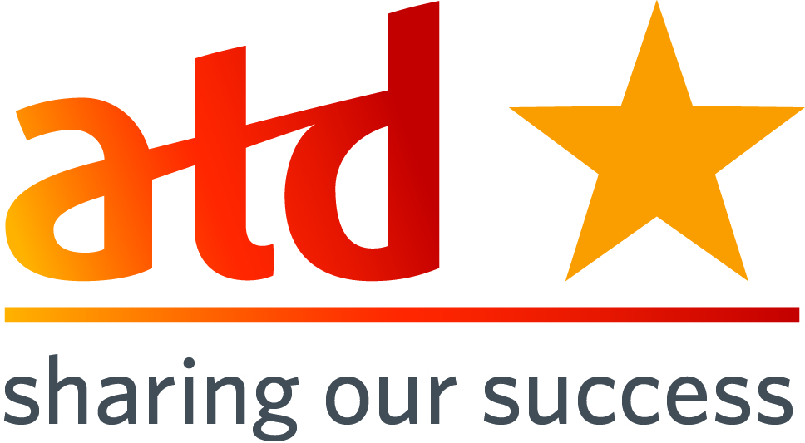**SOS Submission:** Successful Multi Chapter Conferences  
**SOS Title:** Successful Multi Chapter Conferences

|  |  |
| --- | --- |
| **Submission Date:** November 11, 2014 **Chapter Name:** New England Area  **Chapter ID: n/a**  **Chapter Location:** RI, VT, CT, NH, ME, Southern CT, Central MA and Greater Boston  **Chapter Membership Size: n/a** | **Contact for this Submission:** Nancy Giard **Email Address:** giard.nancy@gmail.com **Phone Number:** 978-504-6247  **Chapter Title:** n/a **Chapter Website URL:** [www.atdnewengland.com](http://www.atdnewengland.com)  (yes we have our own regional website!) |

*When responding to each area, please provide information about who, what, when, how, why, where, and to what degree where appropriate. Also, please be specific and provide enough detail that would allow a leader from a different chapter to pick up this document and mimic your effort.*

**Description of Effort:** For the past 3 years, 8 local New England Chapters have joined together to plan and implement a major New England Area conference. The event continues to be a smashing success -- the most recent conference had 5 major sponsors, 12 exhibitors, 20 top-notch presenters and almost 300 participants.

**Need(s) Addressed (please be specific):**

The event supports the ATD brand across the region, increases local chapter membership, encourages networking, includes best-practice presenters, and enables and, in fact, drives cross-chapter collaboration and volunteerism. Best of all, it is exceptionally profitable, bringing thousands of dollars of revenue to each chapter -- allowing them to fund things like ALC attendance. Each year the conference continues to be a very effective membership drive, as we include free local membership with each conference registration.

**What is your chapter’s mission?**

Our mission as a region is to work together to bring the best professional resources to Talent Development professionals in the New England Area.

**How does this effort align with your chapter mission (Please provide specific examples)?**

We have another mission – to be a leader in demonstrating cross-chapter collaboration. As such, we’d like to share what we’ve learned with our fellow ATD chapter leaders. After 4 years of lessons learned, we want to share the key secrets of success -- from planning, organizing, budgeting, scheduling -- to enrolling volunteers -- to obtaining top-notch sponsors, exhibitors and presenters. We have created a summary presentation and zipped it up with all the files we used for our own event -- into a toolkit called “10 Secrets to Running a Successful Multi-Chapter Conference”.

**\*ATD Mission:** ***Empower professionals to develop knowledge & skills successfully.\****

**How does this effort align with ATD's mission (Please provide specific examples)?**

Staging a multi-chapter professional conference directly aligns with ATD’s mission by offering a variety of nationally recognized sponsors, exhibitors, top-notch presenters and the latest content in our industry to over 300 area professionals.

**Target Audience (Who will benefit/has benefited?):** Chapter Members and Chapter Boards ( I think our sponsors, exhibitors, presenters and keynotes would also agree they benefitted from participation in the conference).

**Costs/Resource Used:** *(Include any details regarding use of resources including monetary, donations, contributions, volunteer hours, people resources, etc. and how you went about getting these resources.)*

We offer Platinum, Gold and Silver level sponsorships, as well as exhibition space for a fee. Sponsors and Exhibitors are our main source of revenue for the conference. Participants register for an average cost of $150 which really covers the operating expenses for the conference. We identify target sponsors that align with the theme, and we offer exclusive levels of sponsorship to the top dollar payers.

**How did you implement?** *(Please give a brief description.)*

We have an entire team of volunteers to help us accomplish the event. We have 2 co-chairs that lead 5 sub-teams and are supported by a paid administrative assistant. Each chapter identifies a conference liaison who becomes a member of the conference advisory team. Weekly advisory meetings occur to coordinate and align work across sub-teams. One sub team is “volunteers” who operates like our HR department, and is key to getting volunteers and placing them in the various committees and day-of event spots.

**What were the Outcomes?** *(Please include hard data regarding financial, membership increases, target audience satisfaction levels, publicity for the chapter or for the profession, etc.)*

In 2014, as a region, the conference brought us 59 NEW members and revenue of $9,600, which was split across the 8 chapters. For most of the chapters involved this is the most effective membership campaign of the year. Participants return year after year and have even let us capture them on [video](https://www.youtube.com/watch?v=oM9jitCFGEY) after [video](https://www.youtube.com/watch?v=O8Li-wzMl6Q) enthusiastically proclaiming what they got out of the conference.

**Lessons Learned:** *(Hints and tips for other Chapters who may be considering a similar effort)*

They are organized well included in the PPT and .zip file toolkit.

**Please list the specific ATD chapter resources that helped guide you in the process of completing this best practice (e.g. people, documents, policies, by-laws, etc):**

**How did you become familiar with the Sharing Our Success (SOS) program?**

* Saw or heard of SOS from Twitter
* Saw or heard of SOS from Facebook

**X Saw or heard of SOS from another Chapter Leader**

* Saw or heard of SOS from LinkedIn Chapter Leaders group
* Saw or heard of SOS on an area call with a NAC representative
* Found SOS on ATD website ([www.TD.org](http://www.TD.org))
* Other

***Please email completed forms to*** [***SOS@td.org***](mailto:SOS@astd.org) ***along with any supporting documents.***

**10-31-14**