CIASTD Technology Overview

**As a chapter of ASTD, we are the leading source for learning and performance professionals in Central Indiana – providing education, skill development, and networking opportunities with the intention of forwarding the profession and supporting the economic development of our communities.**

|  | Web Site | E-mail | Ning | LinkedIn | FaceBook | Twitter | DimDim | Podcasts/Vodcasts | Blog |
| --- | --- | --- | --- | --- | --- | --- | --- | --- | --- |
| Description | www.ciastd.org  Created & hosted by Stevens & Stevens | Currently using Constant Contact | centralinastd.ning.com  Created by Kristen Hewett, Dec 2008 | Group | Fan Page only  Created by Lida Pinkham |  | www.dimdim.com |  |  |
| Cost | $420/year based on $35/month cost  (+additional costs for new development | included with management fee | FREE | FREE | FREE | FREE | $228 for a 1 year Pro license which gives us up to 50 attendees and branding of our page | N/A | N/A |
| Setup /  Managed by | Mark Records | Mark Records | Lida, Deb, Kristen | Lida | Lida | Lida/Deb | Lida | N/A | N/A |
| Access | Anyone, except member only area | Board | Members only | Anyone, but membership is by approval only | Anyone can become a fan | Anyone can follow us, but followers are monitored and inappropriate followers removed. | Anyone with an invitation | N/A | N/A |
| Owner of Content | CIASTD Board & Committees | Board & Committees | Board Organized but  Member Driven | Driven by Board & Committees and |  |  |  | Board & Committees |  |
| Mission/  Vision |  |  | networking | networking | networking |  | education, skill development | education, skill development |  |
| Objective(s) | Promote chapter & events. Public presence for official chapter information. | Communicate with members about upcoming events | "Members only" content and tools | Area for industry discussion; vehicle to engage potential new members | Quick hit, messages should engage existing members on a personal level | Quick hit, vehicle for "sticky" messages | * Increase participation in planned monthly program events * Connect with & engage members remotely. * Reach members that might not be able to attend F2F meetings | Knowledge sharing & marketing | Possible format for newsletters with the objective of allowing members to be engaged |
| Strategy |  |  |  |  |  |  |  |  |  |
| Notes |  |  |  |  |  |  |  |  |  |

CIASTD Technology Tools

**As a chapter of ASTD, we are the leading source for learning and performance professionals in Central Indiana – providing education, skill development, and networking opportunities with the intention of forwarding the profession and supporting the economic development of our communities.**

# Announcements

* Website
* Newsletter
* E-mail
* Ning
* FaceBook
* Twitter
* Blog

# Events

* FaceBook
* Ning
* WebSite

# Webinars

* DimDim

# Discussion Forums

* Ning
* LinkedIn
* FaceBook

# Member Only Content

* Website, Member Only area

# Live Chat

* DimDim
* Ning

# Photos

* FaceBook
* Ning

# Video Recordings

* Website
* Facebook
* Ning

# Audio Recordings

* Website
* Facebook
* Ning

# Meeting Handouts

* Website
* Ning

# Other Technology Options

* Delicious, social bookmarking tool
* You Tube Channel
* Twitter fountain – sharing hashtags & photos
* Flickr – photo sharing
* Slideshare – sharing presentations
* TwitterFountain – present tweets with a specific hashtag & photos from Flickr

# Notes

* I created a special e-mail account to use with some of the social networking sites. This is so when there is a change in the VP of Technology position, I can simply pass on the account information to the new person and they won't need to go into each tool to change the e-mail address. They will only have to forward e-mails from that one account to whatever account they want to use.

I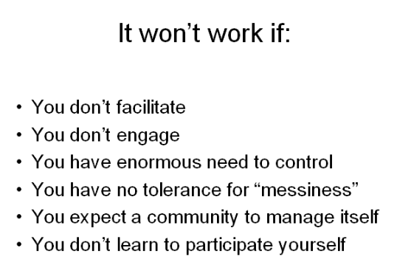

From Dr. Jane Bozarth in reference to talking about using social media.