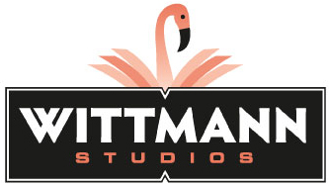

**Kriss Wittmann**

Strategic Illustrator, Wittmann Studios

Biography

Kriss Wittmann is a visual note taker. She graphically “maps” discussions on the spot, providing a visual, memorable summary that engages participants and non-attendees long after the meeting is over. With her deep listening skills she captures key concepts and findings in colorful pictures, cartoons and icons. The process is called graphic recording—and she’s been doing it for business, government, and non-profit clients since 2002.



The artwork is used for visioning, strategic planning and as an historical record of an event. The map becomes a communication tool for leaders to share their vision and roadmap for the future. Since most of us are visual learners, this picture communication method is very effective for engaging the audience.

Some of the organizations Kriss has created illustrations for include:

* Boeing (Maintenance Engineering, Intellectual Property, Organizational Design
* Cities of Arvada, Commerce City, Denver and Lakewood
* Colorado & Wyoming Department of Transportation
* Colorado Health Foundation
* IHS *(Global market information and analytics company)*
* Kaiser Permanente
* Leprino Foods
* United Nations
* United States National Security Agency

Graphic recording requires more than excellent illustration skills. It also requires superb listening and conceptualization skills, business acumen and experience. Kriss’ education (B.A. in Communication Arts, University of Wisconsin-Green Bay and M.S. in Higher Education, Colorado State University) and her 17 years of experience in higher education and corporate training have honed her skills and perspective. She has provided professional skills development to universities in the U.S. and Great Britain, and to organizations such as Right Management, U.S. Postal Service, ADT Security Systems and Sprint PCS.