Steps | Examples
Log into Wild Apricot Search / Find each person and give them permissions to access to the system.

They need to be able to see the new tab from the home screen.
After logging in, from the home page, they will see a tab at the far right side entitled Volunteer Only, with the Public View. It will not display when they are not logged in.

Navigate to the Volunteer Only Tab, and select a subsection. Subsections are sorted by chapter leader disciple or operational vertical:  - Leadership Toolkit  - Conference  - Chapter Meetings  - Membership  - Technology  - SIG/GIG  - Workshop  - President | 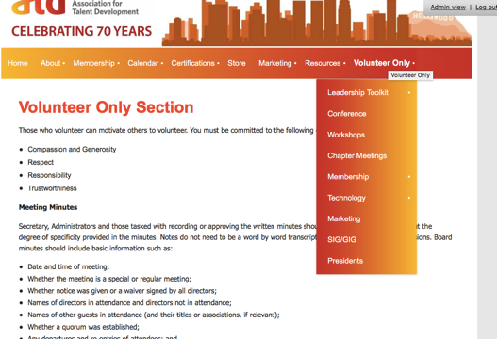
Learning Events and Workshops  Page includes  - Proposed schedule /calendar  - Event planner forms  - Agreement forms  - Venue details  - Speakers details  - Signage templates  - Letter templates | 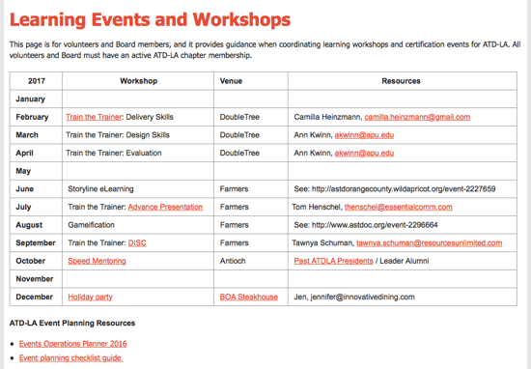
Chapter Meetings  Page includes  - Proposed schedule /calendar  - Event planner forms  - Agreement forms  - Venue details  - Speakers details  - Signage templates  - Letter templates | 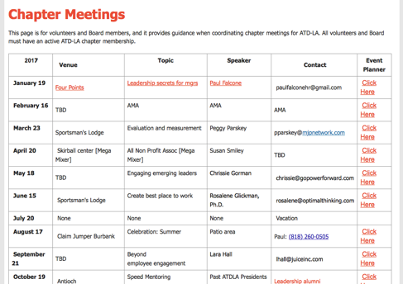
Membership Page  Page includes  - Proposed schedule /calendar  - Campaign templates  - Constant Contact details | 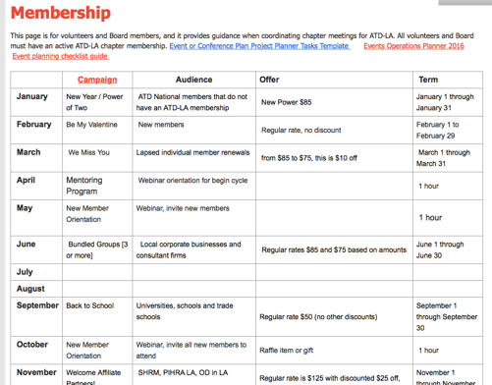
Membership Page > Metrics  Page includes  - Membership Metrics month over month, year over year  - Spreadsheet feeds its data from Google Docs  - Office Admins update Google Doc, and the spreadsheet automatically displays the details  - This page is displayed and discussed at Board Meetings | 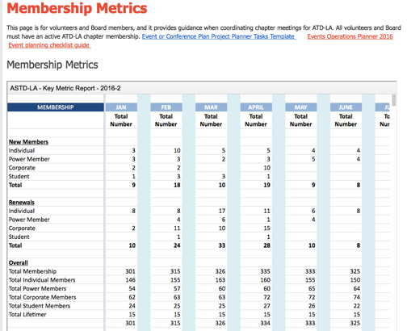
Presidents Page  Page includes  - Office agreement  - Financial spreadsheets  - Log In details to systems  - Insurance docs  - Legacy contents  - Operational plans  - ATD contacts  - Volunteer roster  - Award templates | 