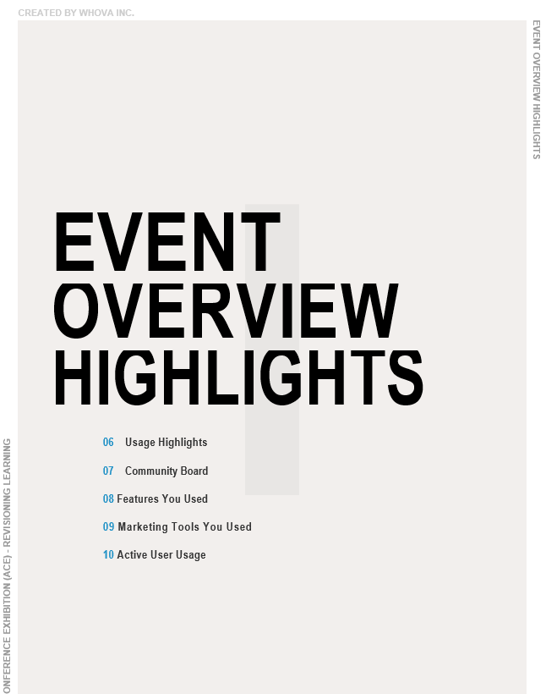

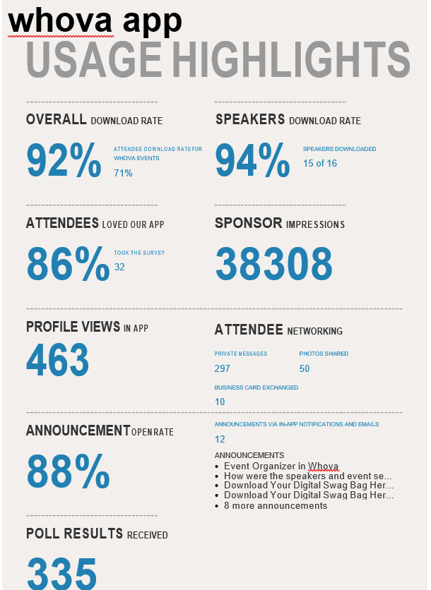

**NETWORKING AND DISTRIBUTION**

NETWORKING AND DISTRIBUTION

**III**

* 1. **Networking Highlights**
  2. **Attendee Breakdown**
  3. **Hybrid Audience Breakdown**

**whova app**

NETWORKING AND DISTRIBUTION

**NETWORKING HIGHLIGHTS**

**PRIVATE MESSAGES 1-ON-1**

## 297

**ATTENDEE INTERACTION 1-ON-1**

Attendees who have interacted with each other in private 1-on-1 messages

**218**

**ATTENDEES INDICATED INTEREST**

## 29

**RECOMMENDED ATTENDEES**

**ATTENDEES MATCHED BASED OFF OF INTERESTS, LOCATIONS, AFFILIATION**

**74**

**TOP RECOMMENDATION MATCHES**

**atlanta, elearning development, atlanta metropolitan area, professional development, learning experience design, and more...**

**ATTENDEE BREAKDOWN**

**ATTENDEE CATEGORIES**

80

|  |  |
| --- | --- |
| **TOP 5 ATTENDEE CATEGORIES** | **ATTENDEES** |
| **All attendees not in other categories** | **92** |
| **Speakers** | **15** |
| **Organizers** | **9** |
| **Planning Committee** | **7** |
| **Volunteer** | **5** |

60

40

20

0

All attendees not in other ...

Speakers

Organizers

Planning Committee

Volunteer

**ATTENDEE AFFILIATION**

**TOP 5 ATTENDEE AFFILIATION ATTENDEES** 8

**Coca-Cola 8** 6

**Cloverleaf 3** 4

**Genuine Parts Company 3** 2

**Georgia Aquarium 3**

**Rollins, Inc 3** 0

Rollins, Inc

Georgia Aquarium

Genuine Parts Company

Cloverleaf

Coca-Cola

**MOST ACTIVE ATTENDEES**

**TOP 5 MOST ACTIVE BY APP ACTION ACTIONS**



ATD ATLANTA ANNUAL CONFERENCE EXHIBITION (ACE) - REVISIONING LEARNING

**Rhonda C 106**

**Allison Baldwin 60**

**LaQuita Bell 59**

**Shakira Isom 34**

**Cora Johnson 14**

100

80

60

40

20

0

Cora Johnson

Shakira Isom

LaQuita Bell

Allison Baldwin

Rhonda C

**whova app**

NETWORKING AND DISTRIBUTION

**HYBRID AUDIENCE INTERACTION**

**AUDIENCE IN-PERSON/REMOTE**

AUDIENCE

69% IN-PERSON

31% REMOTE

**STREAM WATCHED STATS VIDEO WATCHED STATS**

AUDIENCE AUDIENCE

19% IN-PERSON

81% REMOTE

50% IN-PERSON

50% REMOTE

**IN-APP MESSAGES STATS COMMUNITY POSTS STATS**

AUDIENCE AUDIENCE

60% IN-PERSON



ATD ATLANTA ANNUAL CONFERENCE EXHIBITION (ACE) - REVISIONING LEARNING

40% REMOTE



ATD ATLANTA ANNUAL CONFERENCE EXHIBITION (ACE) - REVISIONING LEARNING

# EVENT MARKETING

EVENT MARKETING

**IV**

24 Agenda Webpage

**26** **Speaker Webpage**

**28** **Event Website**

**31** **Social Media Sharing**

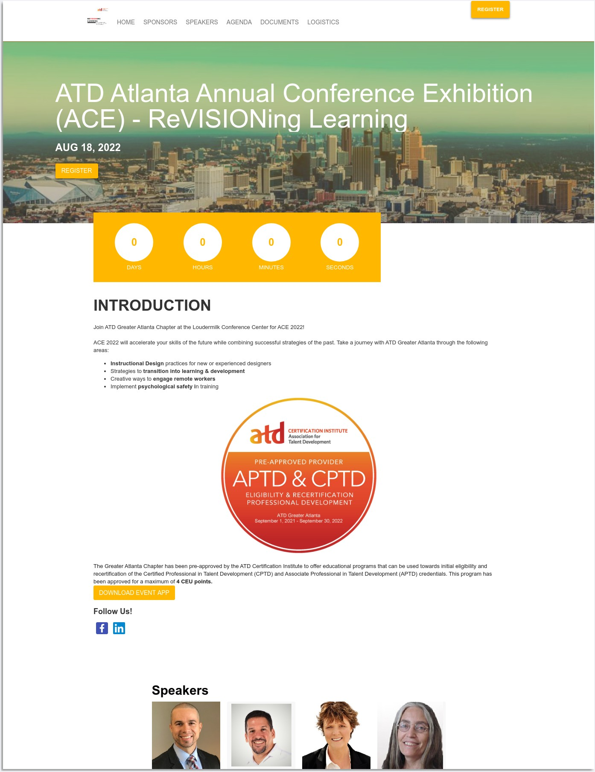

EVENT MARKETING

ATD ATLANTA ANNUAL CONFERENCE EXHIBITION (ACE) - REVISIONING LEARNING

**whova app**

**EVENT WEBSITE**

**YOUR EVENT WEBSITE DESIGN**

EVENT WEBSITE URL

[https://whova.com/web/PLmAuYG1BcKbxbsFgF5OUzzQGQpTyGmVc7B%40qEpmA6g...](https://whova.com/web/PLmAuYG1BcKbxbsFgF5OUzzQGQpTyGmVc7B%40qEpmA6g%3D/)

**TOTAL WEBSITE WEBPAGE VIEWS**

**807**



EVENT MARKETING

ATD ATLANTA ANNUAL CONFERENCE EXHIBITION (ACE) - REVISIONING LEARNING

250

200

150

100

50

Jul 22

Jul 25

Aug 01

Aug 08

Aug 15

**whova app**

**EVENT LISTING**

**REGISTERED WITH EVENT LISTING**

**2**

**LISTING PAGE VISITORS**

## 49

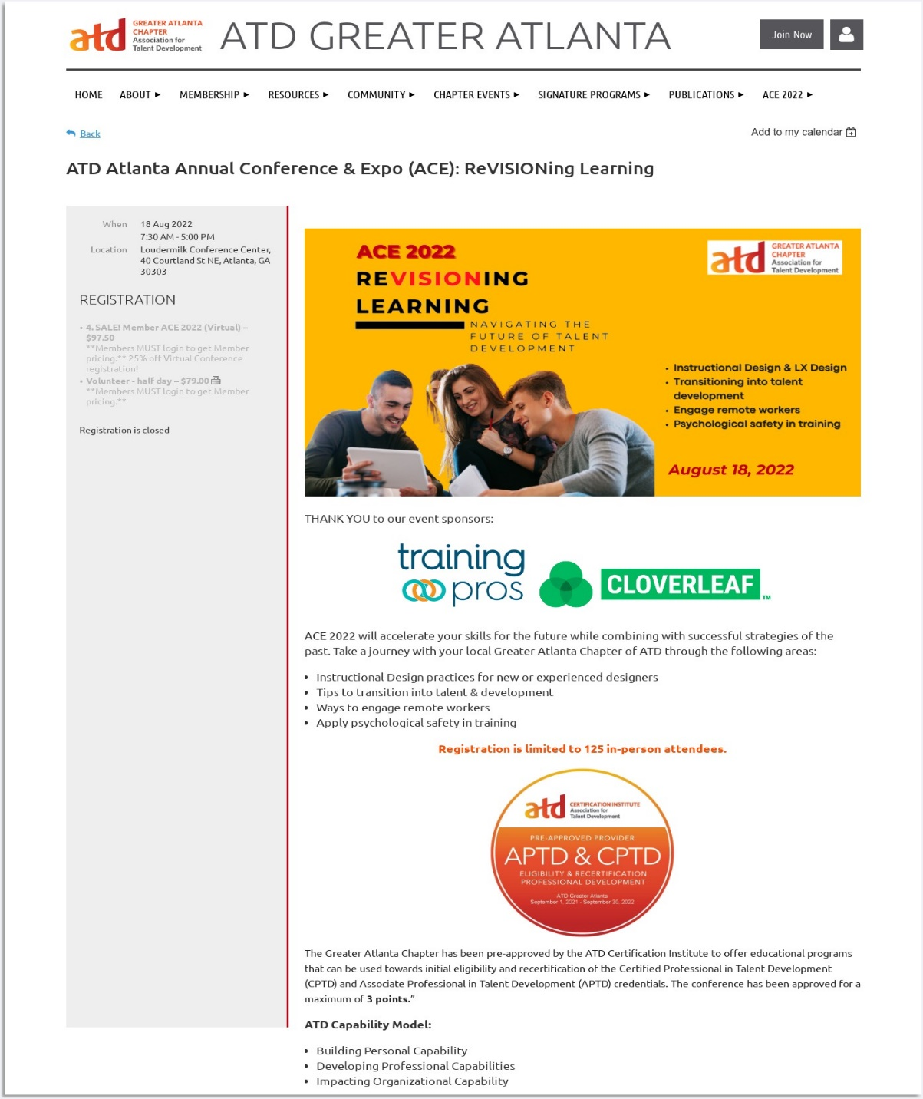

EVENT MARKETING

ATD ATLANTA ANNUAL CONFERENCE EXHIBITION (ACE) - REVISIONING LEARNING

**EVENT LISTING PREVIEW**

### whova app

**SOCIAL MEDIA SHARING**

**PLATFORMS SHARED** 30

PLATFORMS SHARED

1. LinkedIn 34 20
2. Facebook 8

10

1. Twitter 5
2. Other 6 0

LinkedIn

Facebook

Twitter

Other

**SHARED TOTAL**

**53** USERS THAT HELPED SHARE THROUGH WHOVA

**THANK YOU EMAILS SENT**

**3** SENT TO USERS THAT SHARED YOUR EVENT



EVENT MARKETING

ATD ATLANTA ANNUAL CONFERENCE EXHIBITION (ACE) - REVISIONING LEARNING

**SHARED CATEGORIES**

|  |  |
| --- | --- |
| CATEGORY | AMOUNT SHARED |
| 1. Attendees | 43 |
| 2. Speakers | 9 |
| 3. Exhibitors | 0 |



EVENT MARKETING

ATD ATLANTA ANNUAL CONFERENCE EXHIBITION (ACE) - REVISIONING LEARNING

**SPEAKERS SHARED**

NAME PLATFORM

1. Cindy Tingley, ... LinkedIn
2. Courtney Teague Facebook
3. Courtney Teague Twitter
4. Dave Adelman Facebook
5. Cornelius Dowdell Other
6. Dave Adelman LinkedIn
7. Kaleitha Johnson LinkedIn
8. Cindy Tingley, CPS Twitter



EVENT MANAGEMENT

ATD ATLANTA ANNUAL CONFERENCE EXHIBITION (ACE) - REVISIONING LEARNING

**whova app**

**SESSION FEEDBACK**

**SESSION LIST**

**SESSION TITLE - TOP 3 RESPONDED RESPONDENTS**

CREATING A COMPREHENSIVE EMPLOYEE DEVELOPMENT ... 18

**RESPONSES**

SESSION FEEDBACK QUESTION

What was the title of this presentation?

TOTAL TEXT RESPONSES

18

How well did the session meet your expectations?

AVERAGE RATING OF RESPONSES

4.50

What impressed you that you plan to apply to your work or life?

TOTAL TEXT RESPONSES

18

Were the learning objectives met in this session?

MULTIPLE CHOICE RESPONSES

94%, Yes

6%, No

If you answered no to the previous question, please explain here...

TOTAL TEXT RESPONSES

1

How well is the presenter informed on the topic?

AVERAGE RATING OF RESPONSES

4.83

Is the supporting material helpful?

AVERAGE RATING OF RESPONSES

4.89

Any other feedback?

TOTAL TEXT RESPONSES

11

Request verification of ATD CI credits by selecting "Request Cre...



EVENT MANAGEMENT

ATD ATLANTA ANNUAL CONFERENCE EXHIBITION (ACE) - REVISIONING LEARNING

MULTIPLE CHOICE RESPONSES

67%, Request Credits

33%, No credits

**SESSION TITLE RESPONDENTS**

KEYNOTE: REVISIONING AND REDEFINING YOUR APPROAC... 16

**RESPONSES**

SESSION FEEDBACK QUESTION

What was the title of this presentation?

TOTAL TEXT RESPONSES

16

How well did the session meet your expectations?

AVERAGE RATING OF RESPONSES

4.31

What impressed you that you plan to apply to your work or life?

TOTAL TEXT RESPONSES

16

Were the learning objectives met in this session?

MULTIPLE CHOICE RESPONSES

81%, Yes

19%, No

If you answered no to the previous question, please explain here...

TOTAL TEXT RESPONSES

4

How well is the presenter informed on the topic?

AVERAGE RATING OF RESPONSES

4.81

Is the supporting material helpful?

AVERAGE RATING OF RESPONSES

4.19

Any other feedback?

TOTAL TEXT RESPONSES

6

Request verification of ATD CI credits by selecting "Request Cre...

MULTIPLE CHOICE RESPONSES

31%, Request Credits

69%, No credits



EVENT MANAGEMENT

ATD ATLANTA ANNUAL CONFERENCE EXHIBITION (ACE) - REVISIONING LEARNING

**SESSION TITLE RESPONDENTS**

THE 7 FUNDAMENTALS OF EFFECTIVE E-LEARNING 15

**RESPONSES**

SESSION FEEDBACK QUESTION

What was the title of this presentation?

TOTAL TEXT RESPONSES

15

How well did the session meet your expectations?

AVERAGE RATING OF RESPONSES

3.87

What impressed you that you plan to apply to your work or life?

TOTAL TEXT RESPONSES

15

Were the learning objectives met in this session?

MULTIPLE CHOICE RESPONSES

100%, Yes

0%, No

If you answered no to the previous question, please explain here...

TOTAL TEXT RESPONSES

1

How well is the presenter informed on the topic?

AVERAGE RATING OF RESPONSES

4.80

Is the supporting material helpful?

AVERAGE RATING OF RESPONSES

4.53

Any other feedback?

TOTAL TEXT RESPONSES

2

Request verification of ATD CI credits by selecting "Request Cre...

MULTIPLE CHOICE RESPONSES

67%, Request Credits

33%, No credits



EVENT MANAGEMENT

ATD ATLANTA ANNUAL CONFERENCE EXHIBITION (ACE) - REVISIONING LEARNING

**whova app**

**ANNOUNCEMENTS**

**ANNOUNCEMENTS LIST**

**ANNOUNCEMENTS SENT**

Event Organizer in Whova

**How were the speakers and event sessions? Download Your Digital Swag Bag Here!!!**

**Download Your Digital Swag Bag Here!!! Download Your Digital Swag Bag Here!!! Important Session Topic Changes**

**Enter to Win Prizes: Let Everyone Know You Are Coming to ATD Atlanta A... ACE Conference Loudermilk Directions and Parking info**

**Whova Attendee Guide**

**Join Us for Our Virtual Networking Session at 1:15pm REMINDER: Fill out session surveys!**

**APTD & CPTD Recertification Credit Hours**

**ANNOUNCEMENTS TOTAL OPENED**

**11**