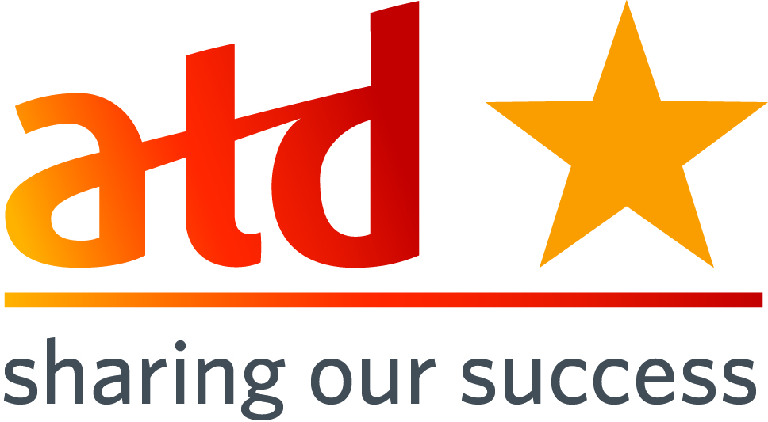**SOS Submission: Communication  
SOS Title: How to use Social Media to Keep Employees Engaged**

|  |  |
| --- | --- |
| **Submission Date: January 14, 2015** **Chapter Name: ATD SWFL CHAPTER**  **Chapter ID: 9206** **Chapter Location: FORT MYERS, FL** **Chapter Membership Size: 49** | **Contact for this Submission: KATHLEEN CHOQUETTE** **Email Address: kchoquette12@centurylink.net** **Phone Number: 239-454-4817**  **Chapter Title: Treasurer** **Chapter Website URL: www.tdswfl.org** |

*When responding to each area, please provide information about who, what, when, how, why, where, and to what degree where appropriate. Also, please be specific and provide enough detail that would allow a leader from a different chapter to pick up this document and mimic your effort.*

**Description of Effort:**

ATD SWFL Chapter held a December meeting titled: In Celebration of Employee Learning Week – “How to use Social Media to Keep Employees Engaged.” This event was offered to ATD members, professional, companies and organizations in the community to demonstrate our commitment to workforce development by providing the opportunity to enhance social media skills in LinkedIn, FaceBook, Pinterest, Twitter and Instagram.

**Need(s) addressed (please be specific):**

Give participants a highly interactive event that enables them to employ employee learning through multiple sources of social media. Spread information about ATD and Employee Learning Week throughout the Southwest Florida community before, during, and after the event though social media channels.

**What is your chapter’s mission?**

Through exceptional learning and performance, we create a world that works better.

**How does this effort align with your chapter mission (Please provide specific examples)?**

* We provided subject matter experts who worked one-on-one with participants to deliver an exceptional learning opportunity.
* To increase awareness about the value of learning in organizations and celebrate “Employee Learning Week.”

**\*ATD Mission:** **Empower professionals to develop knowledge & skills successfully*.\****

**How does this effort align with ATD's mission (Please provide specific examples)?**

By engaging participants in the social media effort to spread the word about the local chapter and Employee Learning Week, we provided a specific opportunity for participants to use the knowledge and skill learned as part of the event.

**Target Audience (Who will benefit/has benefited?):**

The target audience for this effort is all ATD local members, professionals, companies and organizations within the community.

**Costs/Resource Used:**

The event was offered as an end-of –year thank you to members. There was a minimal charge to members to cover the cost of room rental, food and drink. The expert presenters were recruited by members as volunteers.

**How did you implement?**

* News Release was sent to local newspapers in advance.
* Event invitation sent through Constant Contact one month in advance of the Celebration of Employee Learning Week.
* Our monthly newsletter provided detailed information and link to registration for the event.
* Reminders and personal notes were sent to possible attendees two weeks in advance of the event.
* Information for this event was noted on our FaceBook, LinkedIn Group and Twitter which can be seen on our website.
* An event evaluation was sent to all attendees for feedback after the event.

**What were the Outcomes?**

* The SW FL Chapter, ATD and Employee Learning Week were widely spread through multiple social media channels by multiple people who would not normally participated in such a task.
* Our LinkedIn group provided comments about what was learned at the event:

1. I learned that you can use hashtags with Pinterest and was not aware of that before.
2. I learned that Twitter is a good option to communicate with employees that don’t have a company email.
3. I learned that FaceBook allows you to create different settings of friend groups to better control who can see, what and when.
4. I was helped in setting up an Instagram account and excited to begin using this platform as a way to connect with the younger members of our audience.

* 100% of the participants who completed the event evaluation were interest in the topic and effective transferring knowledge. 83% of the participants indicated this learning event was of value to them and will assist them in the future.
* Positive responses from Event Evaluation:

1. Learned some of the basics for Twitter
2. Great help for my problems on FaceBook. I was even showed some easily ways to do things.
3. Learning how and when to us the Social Media sites for advancement of business opportunities was a great take-away. The presenters were excellent.
4. The “options” that can support my effort that I was not aware of impact.
5. Why Instagram is a good idea for my business.
6. Learning more about LinkedIn and finding someone at the meeting who attended the same elementary school I did in Detroit.
7. Format allowed me to pick and choose a particular type of social media to ask my own questions. I spoke to three experts and they were all very helpful.

**Lessons Learned:** *(Hints and tips for other Chapters who may be considering a similar effort)*

* Valuable learning experience to improve our social media skills for personal and business.
* Ensure participants understand how they are contributing to our mission by using what they learn at the event to promote the chapter both during the session and after.
* Reminder in all meeting announcements that the session is hands-on and participants should bring their own devices.

**Please list the specific ATD chapter resources that helped guide you in the process of completing this best practice (e.g. people, documents, policies, by-laws, etc):**

* Kelly Robichaud, VP Programs
* Christine Davlin, President
* Todd Thomas, VP Membership
* Rebecca (Montgomery) Ruding

**How did you become familiar with the Sharing Our Success (SOS) program?**

* Saw or heard of SOS from Twitter
* Saw or heard of SOS from Facebook
* Saw or heard of SOS from another Chapter Leader
* Saw or heard of SOS from LinkedIn Chapter Leaders group
* Saw or heard of SOS on an area call with a NAC representative
* Found SOS on ATD website
* Other – I have submitted one last year.

***Please email completed forms to*** [***SOS@td.org***](mailto:SOS@astd.org) ***along with any supporting documents.***

**10-31-14**