**SOS Submission:   
SOS Title:** **Using QR Codes on Conference Badges**

|  |  |
| --- | --- |
| **Submission Date: 10/21/18** **Chapter Name: Kansas City**  **Chapter ID: CHIP 6027** **Chapter Location: Overland Park, KS** **Chapter Membership Size: Medium** | **Contact for this Submission: Amy Swaminathan** **Email Address: Amy Swaminathan@gmail.com**  **Phone Number: 913-568-8049**  **Chapter Title: VP of Membership** **Chapter Website URL: www.tdkc.org** |

*When responding to each area, please provide information about who, what, when, how, why, where, and to what degree where appropriate. Also, please be specific and provide enough detail that would allow a leader from a different chapter to pick up this document and mimic your effort.*

**Description of Effort:**

Kansas City used a QR code on their conference badges which took attendees to a conference page and their ATD website.

**Need(s) addressed (please be specific):**

The VP of Membership uses QR codes in her current job for various resources and had the idea to use it here since it was free and would provide an easy way of directing people to the conference page and ultimately the Kansas City website.

**What is your chapter’s mission?**

Our mission is to promote excellence in the field of learning and development.

**How does this effort align with your chapter mission (Please provide specific examples)?**

It provides an opportunity for attendees and members to leverage tools that are available to help with eLearning transfer. They also get just in time information. All of which helps promote a better conference and learning experience as well as exposure to what KC ATD has to offer. Helps brand the chapter and elevate professionalism.

**\*ATD Mission:** **Empower professionals to develop talent in the workplace.\***

**How does this effort align with ATD's mission (Please provide specific examples)?**

Empowers attendees to easily find online information to enhance their experience.

**Target Audience (Who will benefit/has benefited?):**

All attendees, speakers, as well as, sponsors.

**Costs/Resource Used:** *(Include any details regarding use of resources including monetary, donations, contributions, volunteer hours, people resources, etc. and how you went about getting these resources.)*

Just the cost of the badge kit (paper/holders). This depends on how many and what type you get. They got around 300 for under 40 dollars. The lanyards were donated, but can use the ones in the kit. The QR feature is free through Avery’s label website as an option when creating. It does not take any more time/costs then regular badges. Less than a few hours with volunteers to get them formatted in the system, printed and put in the badge holders.

**How did you implement?** *(Please give a brief description.)*

Once they decided to do this, they had the person that was designing the event materials design what they wanted on the badge so it was branded. The Avery website has the QR code option on there when creating badges. This is a free website. You have to put in what size labels you are using (indicated on the package you get). Once that is put in you can view your badge sample before printing. They the URL for the conference webpage that they had for the QR scan to go to. By doing this, it had an easy place for all to see the conference related information such as the schedule, speakers, breakouts, sponsors etc. The page is also off of their main KC ATD site so it drives traffic there, hopefully to promote ATD and other events.

I’ve detailed the steps below.

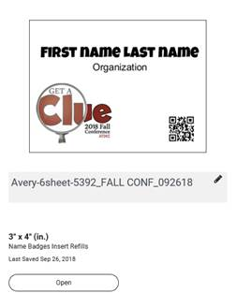

1. [www.avery.com](http://www.avery.com)
2. Click **Start a new project** (recommend creating a free account)
3. Enter label product/template number (we used Avery 6-sheet-5392)
4. Upload a Complete Design
5. Select orientation (we used landscape badge holders)
6. Customize
   * Text
   * Image (we had a custom logo developed) > Add Image (can resize)
   * Import Data/Mail Merge (import Excel spreadsheet of registered guests)
   * Shape
   * QR Code Note: Click to expand list under shape (to get to QR Code and barcodes)

•   Click Create to Add QR Code > Select Code Type > Enter Wesite, and click Finish

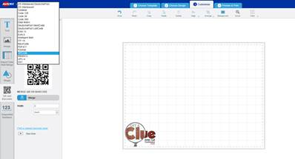 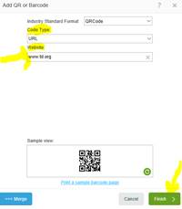

**What were the Outcomes?** *(Please include hard data regarding financial, membership increases, target audience satisfaction levels, publicity for the chapter or for the profession, etc.)*

They received a lot of positive feedback about them as well as additional marketing and publicity to KC ATD from it. Whether the attendee/speaker/sponsor was affiliated with ATD or not, it took them to their website to provide more information as well as easy access to conference information. Also, the thought was many people hang on to nice badges from conferences so it is an easy way down the road if someone is interested or asks the person about it, they can scan and get to the website.

**Lessons Learned:** *(Hints and tips for other Chapters who may be considering a similar effort)*

They tried to tell people about the code as they checked in, but when it got busy, they may not have gotten everyone. They thought maybe next time to have it as part of announcements as the beginning of the conference would be a good way to do it. They also want to start thinking about using for other chapter events as it could have many of the same outcomes. Have blank ones that can be filled out for walk ups. It makes it so much easier for introductions and networking and the QR code is another way to provide information. Could also use self-adhesive badges if there were events that maybe were smaller.

A tip is, you can export a registrant list from Wild Apricot and upload it right into Avery’s website to create the labels/badges.

**Please list the specific ATD chapter resources that helped guide you in the process of completing this best practice (e.g. people, documents, policies, by-laws, etc.):**

No other resources

**How did you become familiar with the Sharing Our Success (SOS) program?**

* Saw or heard of SOS from Twitter
* Saw or heard of SOS from Facebook
* **Saw or heard of SOS from another Chapter Leader**
* Saw or heard of SOS from LinkedIn Chapter Leaders group
* Saw or heard of SOS on an area call with a NAC representative
* Found SOS on ATD website
* Other

**Would you be willing to present on this submission at the ATD Chapter Leaders Conference (ALC)?**

**\*Participating chapters receive up to two complimentary registrations for presenters. Yes**

***Please email completed forms to*** [sos@td.org](mailto:sos@td.org) ***along with any supporting documents.***