2015 ATD Hawkeye CHapter

Executive Leadership Breakfast
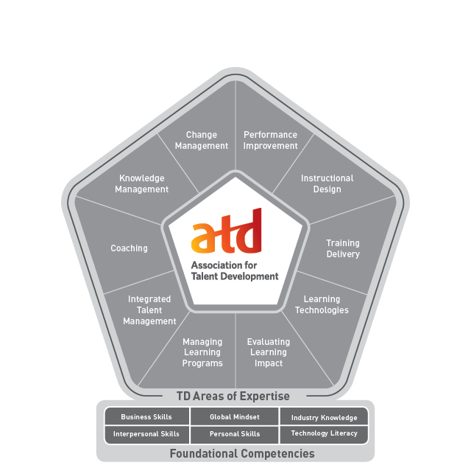 |  | Meeting Objectives:  - Gain insights into the performance gaps and challenges existing within the corridor to help ATD-Hawkeye Chapter with programming and professional development curriculums  - Increase visibility and chapter awareness among senior executives in talent development and workplace learning and performance within the Corridor  - Increase awareness and promote benefits of ATD’s CPLP (Certified Professional in Learning and Performance) Certification  - Discuss role of executives in supporting ATD-Hawkeye chapter
May 13, 2015 8:00 am – 9:30 am
Mount Mercy University House
305 Nassau Dr. SE, Cedar Rapids, IA 52403
 |  |  | Association for Talent Development – Hawkeye Chapter  PO Box 10847  319-350-3861 | hawkeyastd@gmail.com | www.hawkeyeatd.com

