**CIASTD—Plan for Development of Mission, Vision, and Functional Goals for 2010**

**Preparation work:**

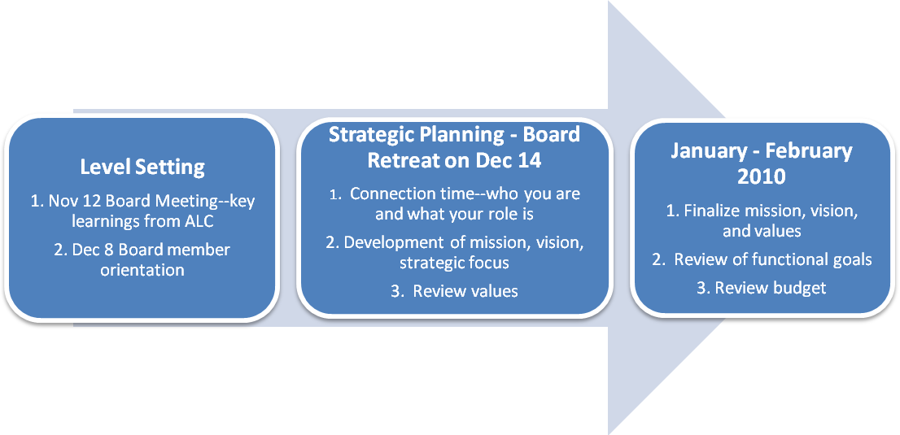

|  |  |
| --- | --- |
| **For board retreat** | * Be prepared to share your personal 30-second elevator speech including the following:   + What CIASTD means to you   + Your role on the board   + How you work with other board members * Review ASTD’s mission, vision, and strategic focus and answer this question: What does this mean for us as a local chapter? What do you think we should focus on in 2010? * Review our current mission and vision and identify how you think they need to change. |
| **For January board meeting** | * Develop your functional goals based on organization’s strategic focus areas * Build your budget based on your goals |