Lake Superior ASTD Scavenger Hunt

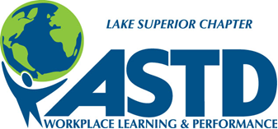

1. Name three benefits of being a National ASTD Member.

2. Locate one article in a T&D magazine that is on leadership  
development.  What is the title?

3. Name two Communities of Practice.

4. What is the price of a National Membership if you renew before  
December 31, 2013?

5. Name two types of professionals that join ASTD?

1. Find our Local President or Vice President, ask them what they like best about being a national member and ask him/her to sign your form!
2. Find the Treasurer of our local Chapter and ask if he or she has attended an ASTD Conference and what tidbit did he or she learn. Ask him or her to draw a happy face on your form!

1. Where is the "Tellin' Ain't Trainin' conference on December 4th and 5th going to be held this year?

1. List two Webcasts that are currently being offered
2. How many "blogs" are out on the ASTD website?