**2012 SOS Submission: (Chicagoland)**

**(Developing tomorrow’s Learning Leaders)**

**Student Awareness Event - Membership)**

|  |  |
| --- | --- |
| **Submission Date:** 11/15/2012 **Chapter Name:** Chicagoland (CCASTD) **Chapter ID:** CH5009 **Chapter Location:** Chicago **Chapter Membership Size:** +600 | **Contact for this Submission:** Joseph Tota **Email Address:** jtota@caveolearning.com **Phone Number:** 312.493.9942 **Chapter Title:** VP of Membership / 2013 President-Elect **Chapter Website URL:** [www.ccastd.org](http://www.ccastd.org) |
|  |  |

**Description of Effort:** CCASTD recognized the need to increase student membership for the chapter and provide the opportunity for a student to further develop their skills and build their network. CCASTD has a partnership with the Learning 3.0 conference (a 2 day conference in Chicago), where a free registration is provided to CCASTD in exchange for assistance in promoting the event. CCASTD hosted a drawing open for students (both existing members and non-members) with the winner receiving free registration to the 2-day conference. This was done in an effort to increase the awareness of CCASTD to our local student population.

**Need Addressed:**

Recognizing that students are the future of our profession, we wanted a way to increase CCASTD’s awareness within the student population of local colleges and universities. We also recognize that students don’t typically have the disposable income that those of us already working have and, as such, we wanted to help one student attend the $1,195 conference for free.

**Does this effort align with your chapter mission**? CCASTD’s mission is to be the “go - to” organization for workplace learning and performance professionals in the Chicagoland area. We believe that providing an opportunity for a student aligns to our mission.

**Does this effort align with ASTD's mission?** Yes

**Target Audience:** Students –Non-Members and Members

**Costs/Resource Use:** One freeLearning 3.0 Conference registration which was donated to CCASTD. We created a Survey Monkey Survey to track the students that signed up. We posted the survey on LinkedIn, Twitter, Facebook and sent to our student members to send out to their peers.

**How did you implement?** We created a Marketing Plan to promote the Student Giveaway. We leveraged Social Media and sent out a personal email to our student members creating awareness for the drawing.

**What were the Outcomes?** We had 45 students that registered for the promotion. These students now have awareness for the chapter and have been added to our mailing list to receive our regular communications. Five students joined as a direct result of the giveaway.

**Lessons Learned:** *Social Media, Board Participation, Willingness to help students. This was our first year and first attempt to do this. We anticipate stronger interest in subsequent years. For the future, we will start earlier. We held this promotion one month prior to the conference. More time would allow for more marketing opportunities. We also plan to send the communications to faculty at our local colleges and universities as they are a great source of support and ideas for students, as well as being an untapped market for membership in CCASTD. Lastly, we had a smaller group supporting this effort and, in the future, will involve more board members to help spread the word.*

**Please list the specific ASTD chapter resources that helped guide you in the process of completing this best practice:** Social Media Toolkit

***Please email completed forms to*** [***SOS@astd.org***](mailto:SOS@astd.org) ***along with any supporting documents.***

**Email to Student Members announcing event**

Dear Student,

***You are receiving this email because your current CCASTD membership profile has listed Triton College as your organization. We believe that this is special announcement is relevant to you.

CCASTD is thrilled to announce that we are giving away (for free) to a lucky student one [Learning 3.0 Conference](http://bit.ly/PT0Ds4) Registration through a random drawing that will end on October 11th, 2012 at 5:00PM CST.

CCASTD is committed to supporting students who have an interest in the workplace learning and performance field. We believe that providing the opportunity for a student to attend will build additional interest in the workplace learning and performance field and offer a chance to meet other professionals in the industry. The Learning 3.0 Conference is being hosted in Chicago at the McCormack Place October 24 – 25.

**We need your help**

We are kindly asking you to pass this information on to any students that you know who would have interest in this free drawing. We’ve attached a flyer about this special offer.

Students may register by clicking this link – <http://bit.ly/CCASTDstudent>

This is a free giveaway valued at $1,195 for students only (Full and Part time). Winning student must show proof of current enrollment to collect the free conference registration. Terms and Conditions are listed on the registration page. This offer applies to both CCASTD Student members and Non-CCASTD members.

Please pass this information on to other students that you may know or share the attached flyer.

Thanks for your support,

Joe

**Joseph B. Tota**

**Vice President of Membership**

Chicagoland Chapter of ASTD (CCASTD)

www.ccastd.org

**Social Media Posts – LinkedIn / Facebook**

**CCASTD *Student* Learning 3.0 Conference Giveaway – Free Drawing Ends on October 11**

The Chicagoland Chapter of ASTD (CCASTD) is thrilled to announce that we are giving away (for free) to a lucky student one Learning 3.0 Conference Registration through a random drawing that will end on October 11th, 2012 at 5:00PM CST. Learn more about CCASTD here: [www.ccastd.org](http://www.ccastd.org)

CCASTD is committed to supporting students who have an interest in the workplace learning and performance field. We believe that providing the opportunity for a student to attend (for free) will build additional interest in the workplace learning and performance field and offer a chance to meet other professionals in the industry. The Learning 3.0 Conference is being hosted in Chicago at the McCormick Place October 24 – 25. Learn more about the conference here: <http://bit.ly/PT0Ds4>

If you have interest to be entered in this free drawing, please click this registration link to enter – <http://bit.ly/CCASTDstudent>

This is a free giveaway valued at $1,195 for students only (Full and Part time). Winning student must show proof of current enrollment to collect the free conference registration. Terms and Conditions are listed on the registration page. This offer applies to both CCASTD Student members and Non-CCASTD members.

Please pass this information on to other students that you may know.

Good Luck,

Joseph Tota

Vice President of Membership

Chicagoland Chapter of ASTD (CCASTD)

**Flyer**

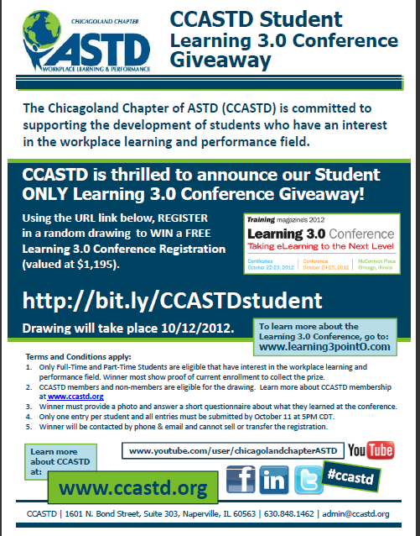

**Winner Announcement**

