**2012 SOS Submission: (Greater Chattanooga)**

**(Modified Wild Apricot Template**

**Certificate of Attendance)**

|  |  |
| --- | --- |
| **Submission Date: December 12, 2012** **Chapter Name: Greater Chattanooga** **Chapter ID: CH4087** **Chapter Location: Chattanooga, TN** **Chapter Membership Size: 80** | **Contact for this Submission: Karla Byrd** **Email Address: karlascomputercafe@comcast.net** **Phone Number: 423.664.3833** **Chapter Title: Certificate of Attendance** **Chapter Website URL: www.astdchatt.org** |

**Description of Effort:** Members requesting proof of attendance to monthly meetings. Members stating that they needed credit to satisfy Employer’s needs for personal/professional growth of employees.

**Need Addressed:**

Modified Wild Apricot e-Mail Template to create an ASTD Certificate of Attendance.

**Does this effort align with your chapter mission? Yes**

**Does this effort align with ASTD's mission? Yes**

**Target Audience:** All Members, Potential New Members

**Costs/Resource Use:** *(Include any details regarding use of resources including monetary, donations, contributions, volunteer hours, people resources, etc. and how you went about getting these resources.)*

* Time investment to modify / customize a Wild Apricot e-Mail Template

**How did you implement?** *(Please give a brief description.)*

Made the necessary modifications and emailed attendee’s within 24 hours of the monthly meeting date.

**What were the Outcomes?** *(Include financial, membership increases, target audience satisfaction levels, publicity for the chapter or for the profession, etc.)*

A professional looking certificate of attendance that members could print off of an email message or forward to their manager when necessary.

**Lessons Learned:** *(Hints and tips for other Chapters who may be considering a similar effort)*

It is extremely important that your attendance records are accurate. Found that members registering for an event and paying online – sometimes things may pop-up and they actually do not attend. So then your email has to go out manually rather than sending out through Wild Apricot Attendee list. *Would be nice if you could mark them as a no-show but still show that they paid for the meeting.

**Please list the specific ASTD chapter resources that helped guide you in the process of completing this best practice:**

Wild Apricot and knowledge of what needs to be on a certificate of attendance. Please see below, example:

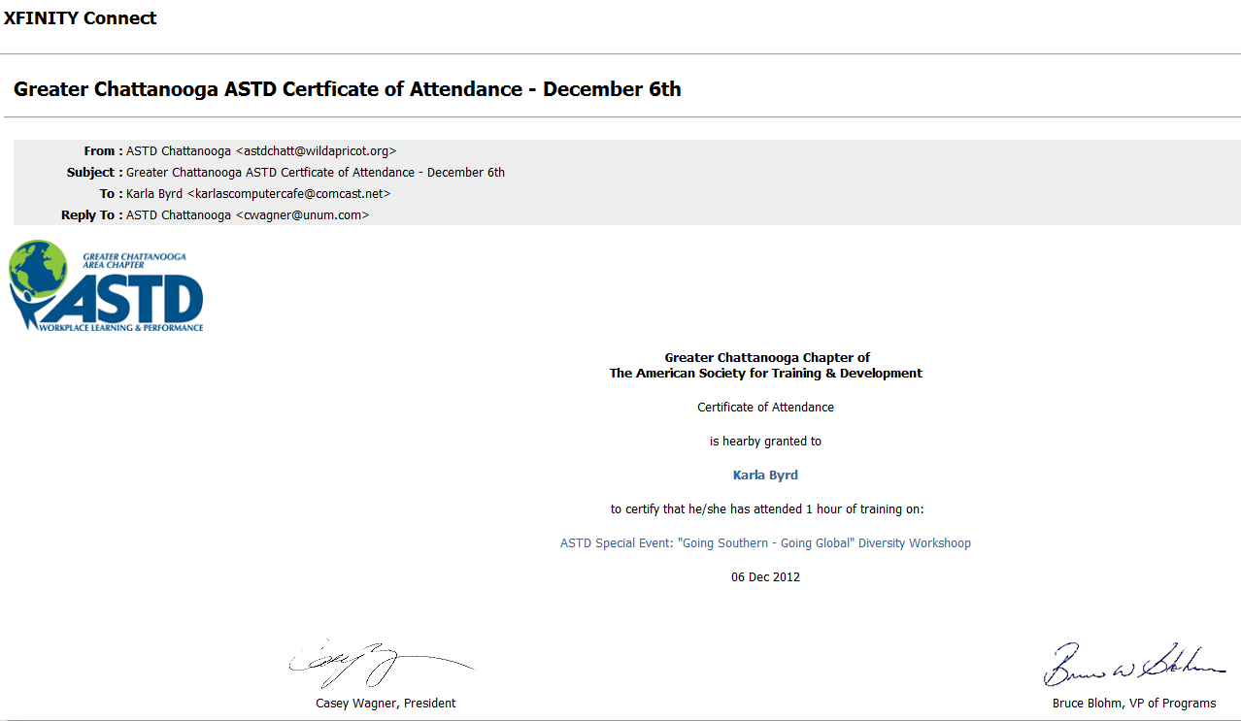

***Please email completed forms to*** [***SOS@astd.org***](mailto:SOS@astd.org) ***along with any supporting documents.***