SOS from ATD San Diego
November 2025

Goal:
Record two short (<10 minute) videos with each Board member providing information related to the role, key resources and files used, important tasks, and reflections on the job and lessons learned.
Business need:
- Support succession planning by having a personal video message about each Board role from a person who has done it describing the role to prospective applicants.
- Increase time to productivity for new Board members who may be still learning what tasks are needed from them and how to use our systems.
- Prevent lost knowledge and “reinventing the wheel” by documenting not merely common SOPs, but where to find key files and resources for each Board position. This amounts to a quick onboarding training with a high level overview of where to look for what and key tasks needed to be completed for the year tips and suggestions for the coming year.

Video #1 Questions
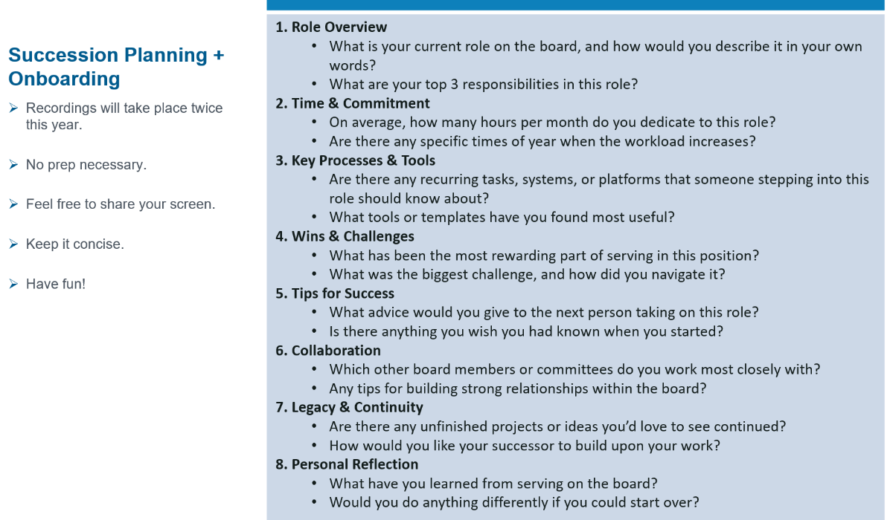

Video #2 Instructions
Do a 5-minute walk through the Board Workspace (shared drive files) for your role and highlight key resources and where to find SOPs related to common tasks. Point out key to-dos or deadlines (e.g. annual compliance calendar) and any external resources if applicable.

Project Announcement Email.
Hello BOD,
I’m in the process of setting up 1:1s with each of you for a quick Zoom video to help future board members onboard with ease. It’s super casual with no prep required. I’ll be off camera asking a few easy questions, and you just talk through your experience like we’re catching up.
If you're curious, the questions I’ll be interviewing you on are attached. We’ll cover the first six questions in our chat, and I’ll record a separate video later this year for the last two.
Additional Request - please record a short video on your own and send me the link once it's complete for the following: In the video, walk through any tools you use, where you store important items, and key resources someone new would need to reference to perform tasks in your role (like SOPs or helpful docs).
One final note...think YouTube, not Hollywood. We don’t need a production crew...just keep it real and keep it you. Short, simple, and to the point is best. All in, this filming process should take less than an hour to complete.

