|  |  |  |  |  |
| --- | --- | --- | --- | --- |
|  |  | |  | | --- | | Greater Boston ASTD Annual Report | |  | |
|  |  |  |
| **annual operational report** |  | **2011** |

This year we created and approved an Operating Plan which provided the framework for doing business efficiently and managing the chapter effectively.   
 **4** Strategies targeted at driving chapter growth and driving continuous improvements were developed this year

**Continuous Improvement**

Our Continuous Improvement Strategy focused on three main efforts:

* Establish and achieve measurable, role-based goals
* Implement financial process improvements
* Streamline communication processes internally and externally

**Communication/Marketing**

We undertook a variety of initiatives to improve communications internally and externally:

* Post monthly meeting announcements and Board agendas in advance of meetings
* Publish Board minutes and monthly meeting summaries to our website in a timely fashion
* Pro-actively manage communications to members
* Enhance how we share information by migrating to the Wild Apricot web hosting solution
* Enable sponsors and vendor partners to purchase marketing from us by developing a detailed Marketing Kit listing marketing vehicles and costs

**Recruitment/Retention**

The chapter strives to be the leading organization for training professionals in our area. We recognize that providing valuable programs on contemporary topics is at the core of attracting and retaining members. Our recruitment/retention efforts focused on the following key activities:

* Maintaining up-to-date member lists which improves member communications and helps us pro-actively track and monitor our joint membership rate with National ASTD
* Conducting a Member Satisfaction Survey to identify new continuous improvement efforts
* Conducting satisfaction surveys after each meeting and conduct a monthly debrief of results with the Board
* Conducting membership and meeting fee benchmarking research then consider and/or enact any desired changes to our fees structures for the year
* Spearheading the first annual Multi-chapter New England Area Conference and including other area chapters in planning and executing this event
* This event offered members opportunities to further their own professional development by participating in workshops with prominent area presenters and broaden their professional networking contacts
* This valuable mini-conference provided a low-cost, high-quality professional development day for training professionals in the six New England states
* Collaborating with our other area chapters to co-host this event strengthened our inter-chapter relationships

**Succession Planning**

Our succession planning is founded on three main ideas: run an efficient and effective Board, provide value to Board Members for their contributions, and maintain a vigorous recruitment program.

**Run an Efficient and Effective Board**Working on the Board is rewarding. At the same time, we recognize that it is a serious commitment and we honor our board’s commitment by operating board business efficiently and flexibly.

* Much business is conducted virtually
* In person meetings are effective and efficient, and open discussions occur before Board decisions are made
* To “set up for success,” we conducted a series of orientation activities to familiarize the Board with ASTD National policies, the Greater Boston Chapter processes and strategic direction for the year and CORE requirements

**Provide Value to Board Members the following were provided in 2011:**

* Scholarships funding Board Members’ attendance at a variety of ASTD professional development opportunities, classes and certifications
* National ASTD memberships funded
* Free chapter meeting admittance all year
* Work-for-scholarship opportunities for the New England Area Conference
* Online profile on the chapter website
* Business cards embossed with the chapter logo and board title
* Leadership opportunities, such as leading a committee or special project

**Maintain a Vigorous Recruitment Program**

* Each Board Member was challenged to meet at least one member at each meeting to deepen our committee pool and get to know the skills of our membership
* This challenge encourages board members to be on the look-out for their own successors and provides a motivation to interact with members
* Conducting well run elections, including creation of up-to-date and detailed job descriptions, were a key component to seating a legitimate board this year

*Successfully completed   
10 out of 11 goals, including all Chapter Operating Requirements (CORE)*

|  |
| --- |
| Financial management |
| All financial goals for 2011 were met successfully. This year we transitioned our financial management to QuickBooks which has streamlined our processes and ability to manage our finances. |

C:\Users\GIANA02\AppData\Local\Microsoft\Windows\Temporary Internet Files\Content.IE5\WI6AZ5L4\MC900442070[1].WMFCOMPLETED TASKS

* Conducted Risk Management Assessment
* Developed Annual Operating Budget
* Implemented QuickBooks
* Filed all 2010 taxes
* Completed independent financial review of chapter finances

*100% Complete*

|  |
| --- |
| staying connected |
| We sent approximately 20 e-Newsletters announcing upcoming meetings/events and chapter news. We engaged our members through a variety of social media channels and through our website at [www.massastd.org](http://www.massastd.org). We published our Board Meeting Minutes within two weeks of our meetings and posted blog entries recapping Monthly Meetings. |

*100% Complete*

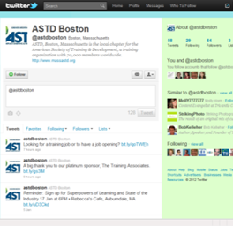

We are pleased to report a 38% National Co-Membership rate for 2011, exceeding the targeted rate of 35%. We put special focus on verifying our membership list as part of our check-in process at member meetings. CORE requires that our board of directors maintain currency with National Membership. The chapter provided scholarships for all board members to have one year of National ASTD membership. We are actively conducting our 2011 member survey and will share results and next steps at our March or April 2012 member meeting.

### **Membership**

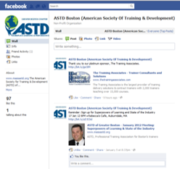

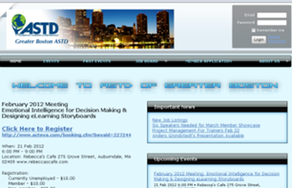

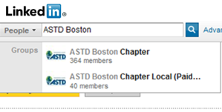



110  
**Greater Boston ASTD Members**

[***Membership***](http://www.massastd.org/MembershipApp) ***Offerings***

* ***Standard $80***
* ***Group (3 or more) $65***
* ***Student $55***

*100% Complete*

**Monthly Member Meetings**

* Open to Non-members Too
* Low Fees
  + Members $10
  + Unemployed $10
  + Non-members $25
  + Walk-in fee +5
* Average Attendance = 45
* Held 3rd Thursday@6pm
* September – June
* Includes Networking Dinner

|  |
| --- |
| Professional development programming |



|  |
| --- |
| fast facts |
| We offered a wide variety of professional development opportunities for Greater Boston area Workplace Learning professionals. |

5

Typical-format member meetings were held in 2011 bringing professional development to our members on a wide variety of topics.Each meeting included:

* Networking Dinner
* 30-minute “Tech Talk” training Technology demonstration
* A long networking break
* Keynote presentation/feature

|  |  |
| --- | --- |
|  |  |

4

Special-format member meetings were held

* Hands-on eLearning Workshop
* Multi-Chapter Summer Social Mixer
* Member Showcase Night
* Multi-Chapter One Day Mini-Conference

|  |  |
| --- | --- |
|  |  |

5

Keynote presentations

* Humor in Training and Presentations
* LMS Panel Discussion
* Using Video & Green Screen Technologies
* Mobile Learning
* Networking Skills and Speed Networking

|  |  |
| --- | --- |
|  |  |

4

Tech Talk Topics

* Second Life
* Lectora eLearning Design
* Moodle
* Blackboard

|  |  |
| --- | --- |
|  |  |

16+

Networking opportunities were designed into our program offerings. We devoted our November meeting to the subject, offering a Networking Techniques workshop followed by a Speed Networking exercise. In June we hosted a well-attended Multi-Chapter Summer Social Mixer.

|  |  |
| --- | --- |
|  |  |

1

Hands-on format member meeting was held at a local computer lab. Over 40 members packed the 2.5 hour session gaining real hands-on experience with 3 commonly used eLearning rapid development tools.

|  |  |
| --- | --- |
|  |  |

6

Members presented at our popular Member Showcase meeting held in March. This American Idol format meeting put our members at the front of the room to share 15 minutes of their best stuff.

|  |  |
| --- | --- |
|  | **N**ew **E**ngland **A**rea ASTD **C**onference |

**One-day Mini-conference -4/29/2011**  
ASTD New England Area local chapters joined forces to bring a very special event designed to share our resources, emerging experience and best thinking in a highly engaging, eye-opening conference. On Thursday evening, April 28, we held a Networking Reception, including audio visual treats, speed networking and an opportunity to participate in a real-time Lrnchat on Twitter with international learning professionals. **Keynote Speaker:** -- **Tony Bingham**, CEO and President of the American Society for Training and Development (ASTD). Tony shared his insights into future training industry trends, including highlights from his latest book.  
**8 Breakout Sessions Were Held:**

* Sightseeing Social Media Overview: Cammy Bean
* Hands-On Twitter:  David Kelly
* Value of Linked In: Patrick O’Malley
* Dealing with Naysayers: Gina Minks
* Case Study: Where Social Media is Working: Dave Wilkins
* Facilitating an Online Session: Sue Nolan
* The Emerging Role of the Community Manager: Jim Storer
* Hands On – Exploring Social Media: Jean Marrapodi

To wrap up the conference, the **closing speaker** **David Wilkins** shared his comical and insightful views about the future of our industry.

|  |
| --- |
| Marketing |
| We increased visibility of the ChiP discount program by marketing the program prominently on our website. We also handed out poker chips with our ChiP code attached by a sticker at many of our chapter meetings!  Board members were provided the perk of custom-made ASTD Business Cards!  We made it easier for sponsors and vendor partners to purchase marketing from us by developing a detailed Marketing Kit which lists our marketing vehicles and costs. |
| **Media Kit**  advertising with us   * **Event Sponsorship**   + Platinum   + Gold   + Silver * **Website Advertising** * **Newsletter Ads** * **Custom email Blasts** |

*100% Complete*

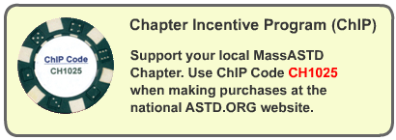

*We migrated to a new web hosting solution and redesigned our website entirely. We are committed to keeping this valuable information completely up to date:*

* Upcoming Events
* Past Events Blog
* Job Listings
* Member Application
* About Us
* Board Meeting Business
* Board Member Profiles
* Join our Mailing List

*100% Complete*