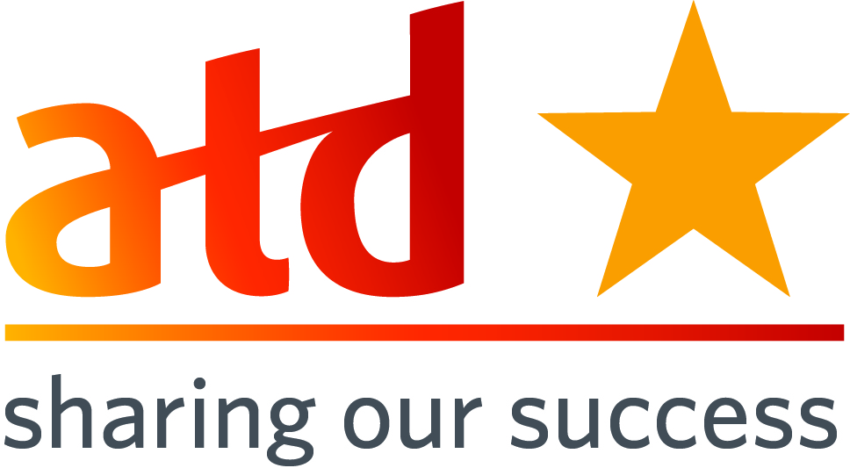
SOS Submission: Click here to enter text.
SOS Title: Click here to enter text.

Submission Date: 08/17/2015  Chapter Name: COC-ATD  Chapter ID: COC-ATD  Chapter Location: OKC  Chapter Membership Size: 169 | Contact for this Submission: Avi Nardia  Email Address: avi.nardia@integrisok.com  Phone Number: 405.552.2949  Chapter Title: President Elect  Chapter Website URL: www.tdokc.org

When responding to each area, please provide information about who, what, when, how, why, where, and to what degree where appropriate. Also, please be specific and provide enough detail that would allow a leader from a different chapter to pick up this document and mimic your effort.

Description of Effort:

Program Engagement and Membership Value Focus aligned to our New ATD Identification

With our change in identification to ATD has been the perfect time to revisit our programs alignment and membership value to be inclusive of our new brand and our core competencies. We incorporated a new needs analysis reinforcing our core competency model and ATD brand. We also used this time to continue to bolster our new identify to ATD and what benefits our chapter has for our local community as well as our National involvement. We felt our local membership was good, but we wanted to highlight the benefits of local and national membership under our new brand – we wanted to rebrand ourselves to our local community. Our focus included:
- Comprehensive needs analysis to 509 email members regarding new ATD local and the brand nationally
- Website redesign
- Price mix redesign to attract new members and power members
- Programming Happy Hour to engage participation in our planning with 15 participants
- Partnering with local SHRM group on a program and rebranding with them to draw cross-membership
- Monthly emphasis on our competency model for Talent Development Professionals
- Monthly emphasis on National Membership benefits
Need(s) addressed (please be specific):
Increase engagement to ensure alignment to all talent development individuals and ensure alignment to our membership needs. We use the first half of the year to expand our Core Competency Model via our programming and communication with our local community and to address their needs in a more comprehensive way.
What is your chapter’s mission?
To ensure relevant programs, resources and networking opportunities for workplace learning professionals

How does this effort align with your chapter mission (Please provide specific examples)?
We have increase engagement and networking opportunities our members. This effort, plus the redesign of the website, helps use ensure we are aligned to the Talent Development industry and to what our local members want.

*ATD Mission: Empower professionals to develop knowledge & skills successfully.*
How does this effort align with ATD's mission (Please provide specific examples)?
This will continue to empower all of our members to develop knowledge and skills. We are challenging people to look beyond what they may need personally to develop but what they need in terms of knowledge and skills in the greater industry to talent development.
Target Audience (Who will benefit/has benefited?):
OD, Learning and Development, Trainers, educators, facilitators practitioners in the OK and OKC metro area
Costs/Resource Used: (Include any details regarding use of resources including monetary, donations, contributions, volunteer hours, people resources, etc. and how you went about getting these resources.)
We had total of 15 volunteers during our programming committee meetings and countless hours of board members investment to redesign the website, tailor the survey, collect the results and identify programming based on feedback received. We have spent $4,000 for a national speaker (change management) and additional of approximately $1,000 for new venue for special programs in addition to our regular held meetings. We conducted a member appreciation lunch and learn free of charge to all active members.

How did you implement? (Please give a brief description.)

Designed survey based on competency model.
Rolled out communication regarding survey
Conducted survey and gathered analysis
Adjusted annual programming to meet member needs
Planned monthly meeting communication to increase awareness of Competency model and program alignment
Adjusted pricing for main events to attract new members and reward existing and Power members discussed prior to events and approved as required by board by-laws.

What were the Outcomes? (Please include hard data regarding financial, membership increases, target audience satisfaction levels, publicity for the chapter or for the profession, etc.)

Our financial remaining strong and membership increased by more than 10% and is 169 active members today!
But more importantly our goal was achieved! Between Jan through Aug of 2014 we have engaged 183 individuals and for the same period in 2015 we have engaged 272 individuals. Almost 50% increase in engagement and program participation. We continue to be challenged with Power Membership and are looking at conducting an analysis on why national membership is still struggling so to redesign our national membership promotion. We have began discussions with our new rep. Erin Murphy and continue to explore innovative ways to promote this.

Lessons Learned: (Hints and tips for other Chapters who may be considering a similar effort)

Continue to solicit feedback from your target audience and commit to continues improvement. If you are concerned about changing the programs time and venues that are already working well for your chapter KEEP them and add mini events (pilot), then check the vitals of your target audience. What worked last year will not necessarily work next year.

Please list the specific ATD chapter resources that helped guide you in the process of completing this best practice (e.g. people, documents, policies, by-laws, etc):

New vision and mission of atd national and the move from astd to atd was timely monumental and inspired our community of practice. Our new Rep. Erin Murphy

How did you become familiar with the Sharing Our Success (SOS) program?
- Saw or heard of SOS from Twitter
- Saw or heard of SOS from Facebook
- Saw or heard of SOS from another Chapter Leader
- Saw or heard of SOS from LinkedIn Chapter Leaders group
- Saw or heard of SOS on an area call with a NAC representative
- Found SOS on ATD website
- Other

Please email completed forms to SOS@td.org along with any supporting documents.
10-31-14

